**List of Teachers**

1. Rashmi C
2. Godarashmi N
3. Lakshmi Raghavan Ananda - (Trustee)
4. Shantala Bhat
5. Prathima D.S. (Trustee)
6. Meenakshi Sivaraman (Trustee)
7. Mamatha T G
8. Chaitanya G N
9. Subashri S
10. Kashinath Gundad
11. S Venkataraman
12. Gouri Hegde
13. Gopalakrishna Hegde - (Trustee) Founder President
14. Sadanand Guddad (Trustee) Vice President
15. Lalita Patawardhan (Trustee)
16. Sheetal Pillai
17. Dr.B.K.Chandrashekhar
18. Mamatha V
19. Sharmila Mhashalkar (Trustee)
20. Anuradha Belamkar
21. Ashwini N
22. Rajalakshmi N
23. Jayashree Murali
24. Vishal S H
25. Ashwini Tapasvi Sahane
26. Vani A Hegde
27. Anitha Hegde
28. Balaka Chatterjee
29. Sukanya Subramanya

**Rashmi C**

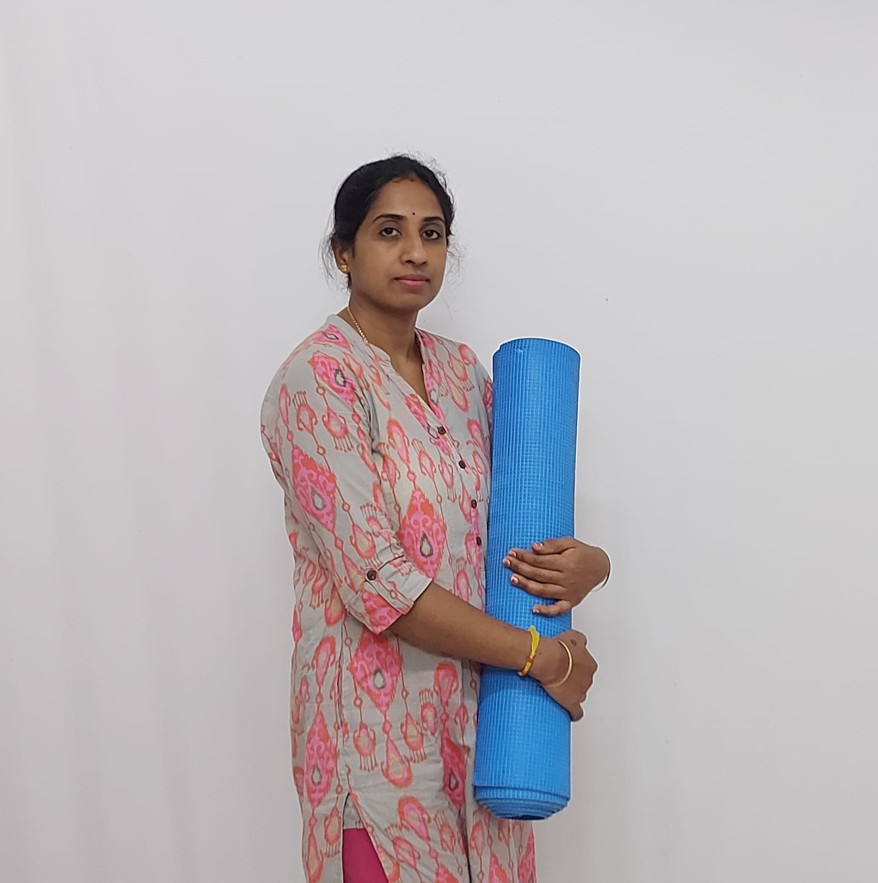

**“Yoga is an exercise to discipline our body & mind.”**

Having been a student practicing regularly and enjoying some benefits, Rashmi has completed her Yoga Instructor’s Course in 2022 and has been teaching ashtanga yoga. She has gained a lot of knowledge & confidence through yoga. She feels that yoga has helped her gain full confidence to face any challenges. Earlier, she had been a homely introverted woman, and now no longer restricting herself to the confines of a home.

Godarashmi N

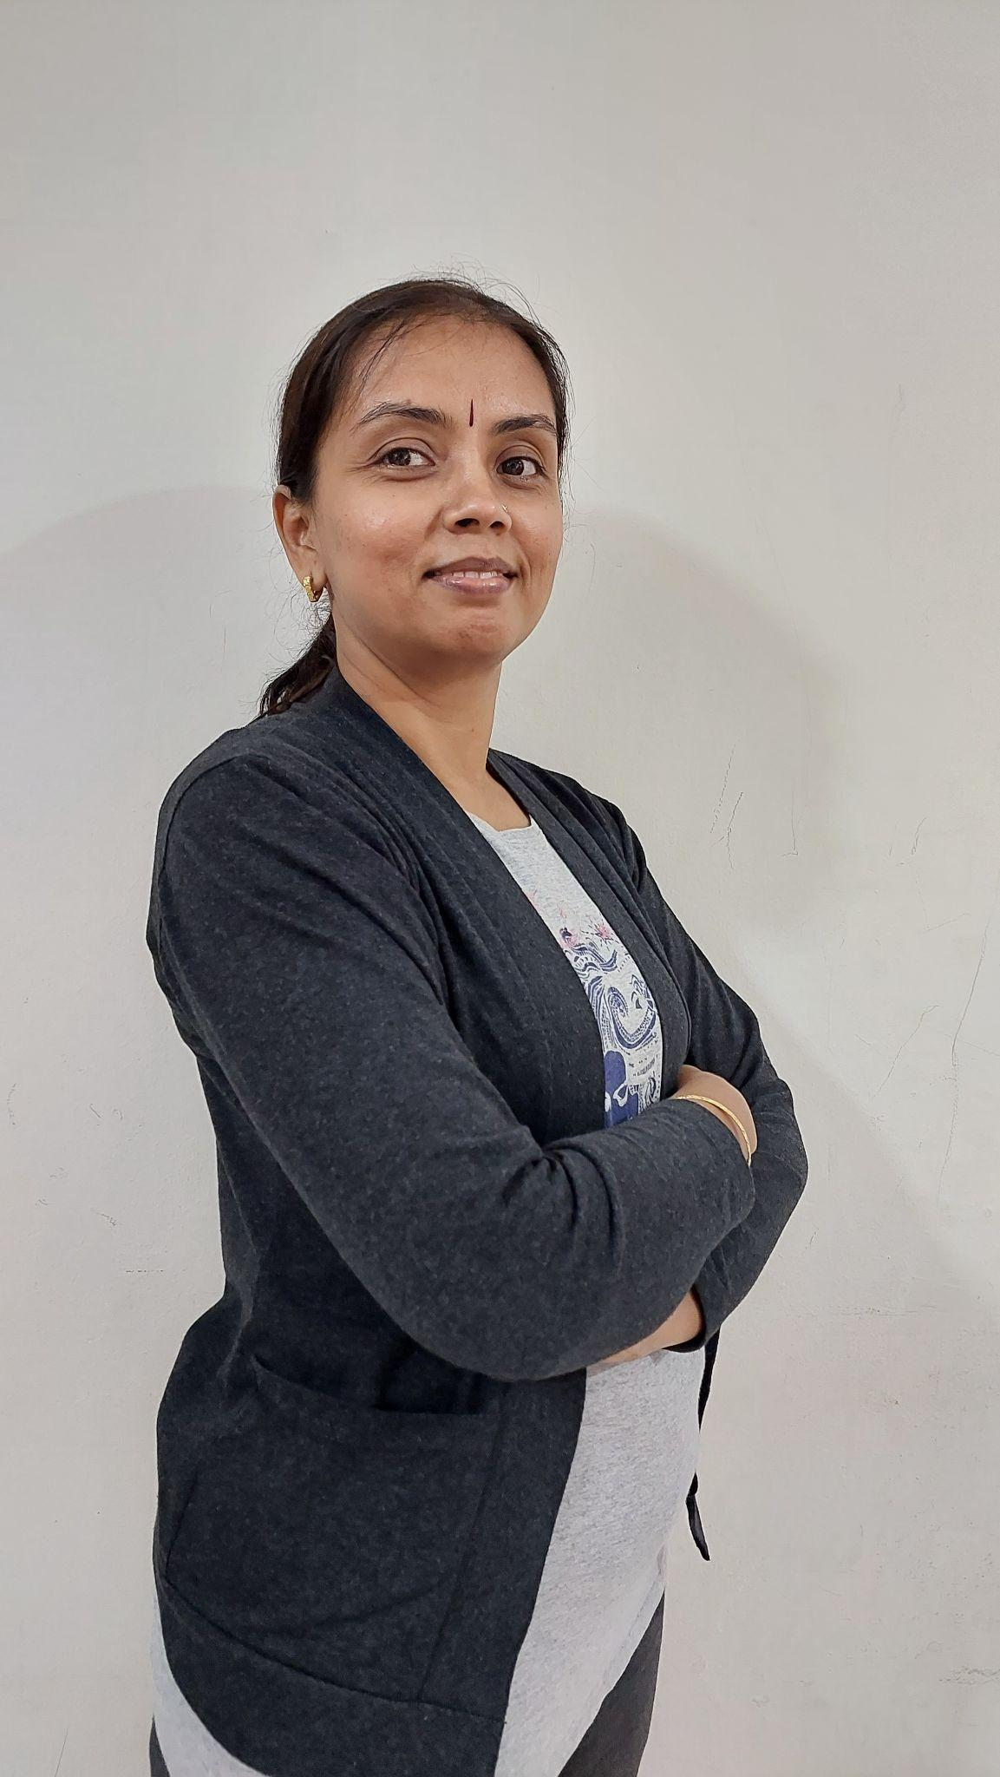

**“Yoga is the only practice that helps us in balancing and managing our mental stress. It helps in accepting the reality of life .It promotes mental growth and improves our presence of mind.”**

Rashmi has been a testimony for SYVK. She joined us as a student and after experimenting as a student for 6 years, she completed her Yoga Instructor Course in our Institution to qualify as a teacher. Her educational qualifications include Msc and BEd in Biology and Chemistry . Her experience for many years as a teacher in Biology and Chemistry helps her to understand and reciprocate the in-depth study of physiology and psychology that Yoga provides, along with practical experiments with our own body and mind. She can relate the various Asanas with the human anatomy and feel the body resonating with the energy when each part of the body is stimulated after the practice.

Her classes are enjoyed thoroughly by all age groups. Ashtanga Yoga class includes students from different age groups. Rashmi considers the ailments and problems faced by all her students and formulates each class with an objective to address every issue of her students so that they enjoy the practice and stretch their body a little more everyday to achieve the final pose. Her motto for the day is that students should be glad and happy with their practice for the day to keep themselves active throughout the day by giving up laziness.

**Lakshmi Raghavan Ananda   
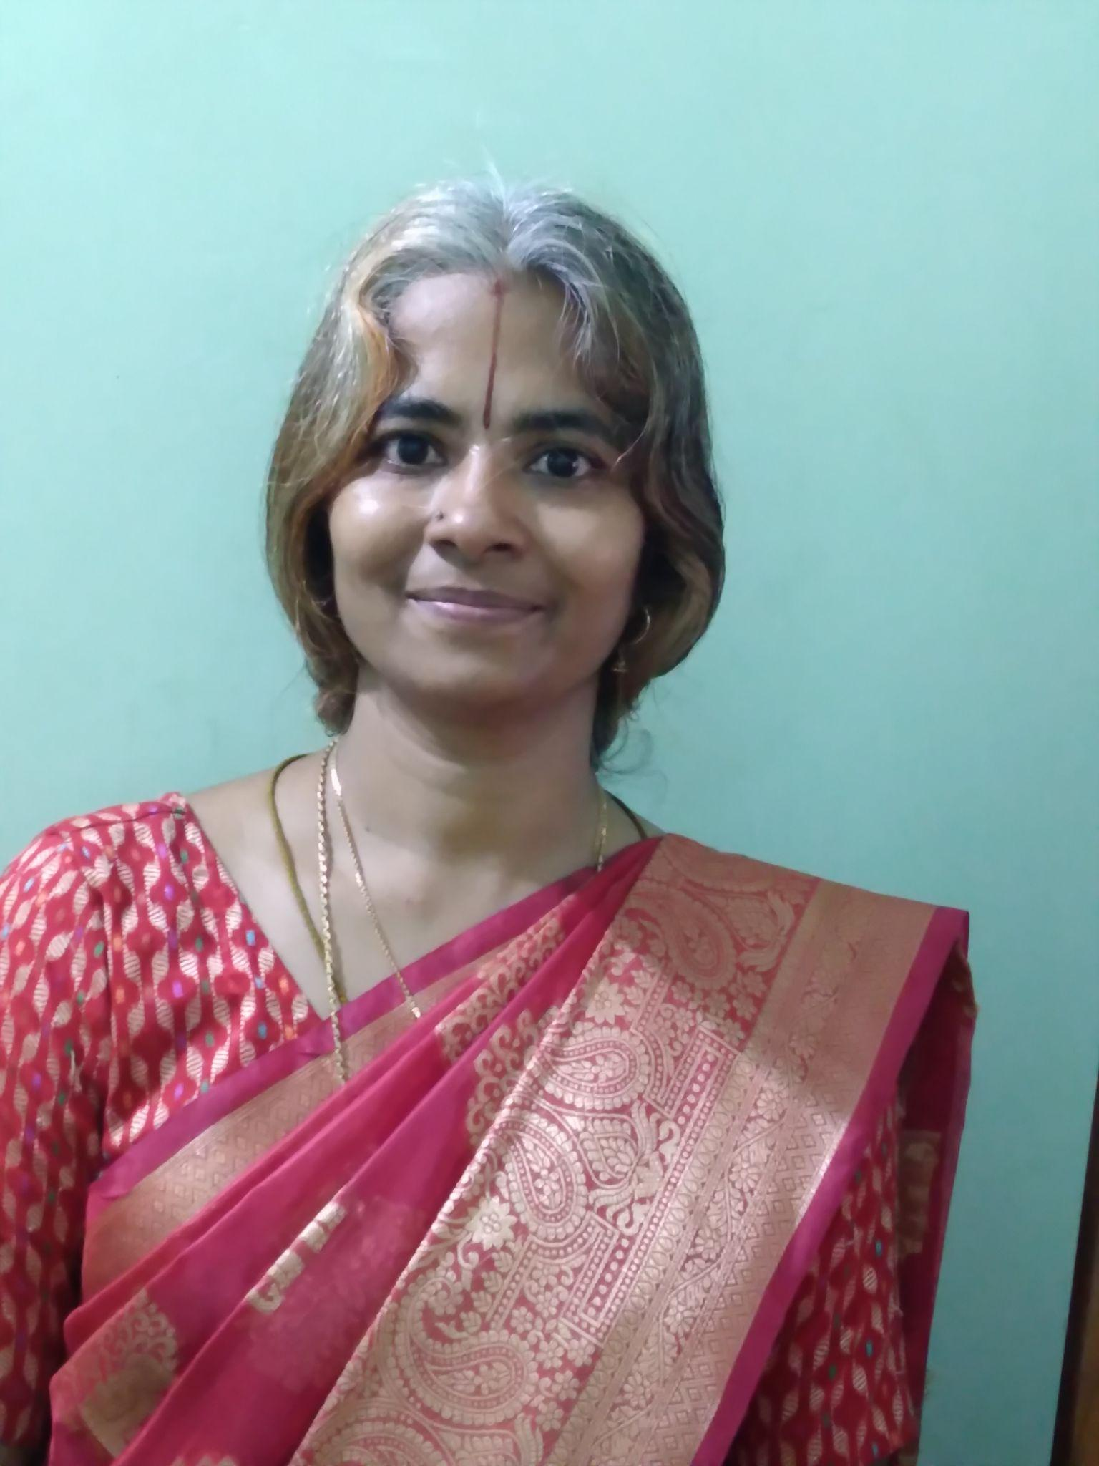**

**“योग/yog is the beautiful meeting of like minded**

**people working in unison for better health, lasting**

**happiness and elevated energy to reach closer to the Paramatma.”**

Lakshmi has been with SYVK from 2017. She is the topper of the Yoga Instructor Course held in the 2017 batch of SYVK. Secured 2nd prize in state level Yoga Competition held in Bengaluru in the year 2018, 1st place in the National Yoga Competition held in Bengaluru in the same year. In 2019, she conducted summer camps at various locations for kids. She has also completed Advanced Yoga Training in the year 2020. She gives talks on International Day of Yoga on various topics related to physical and mental health at schools, colleges and other platforms. Her expertise includes topics like, pranayama, eye exercises, and asanas for diverse populations including elderly, the depressed and anxious and the differently abled children.

She has been conducting theory as well as practical sessions for various age groups and different categories. She also engages herself in individual therapy sessions for suicidal thoughts, depression, anxiety and other lifestyle problems. She is also a Psychological counselor. Her Sessions are always focussed on maintaining the classical Ashtanga yoga practise in accordance with the prescriptions of VYASA, Jigani.

She is exploring the possibility of bringing more of Bharateeyata into the external appearance of people, leading to insightful inculcating of rich traditional values into the minds. She has done her Masters in Psychology from Pune university, in 1999 and a UGC-NET qualified senior lecturer in 2000 also obtained her B.Ed from Central Institute of Education in 2006.

**Shantala Bhat**

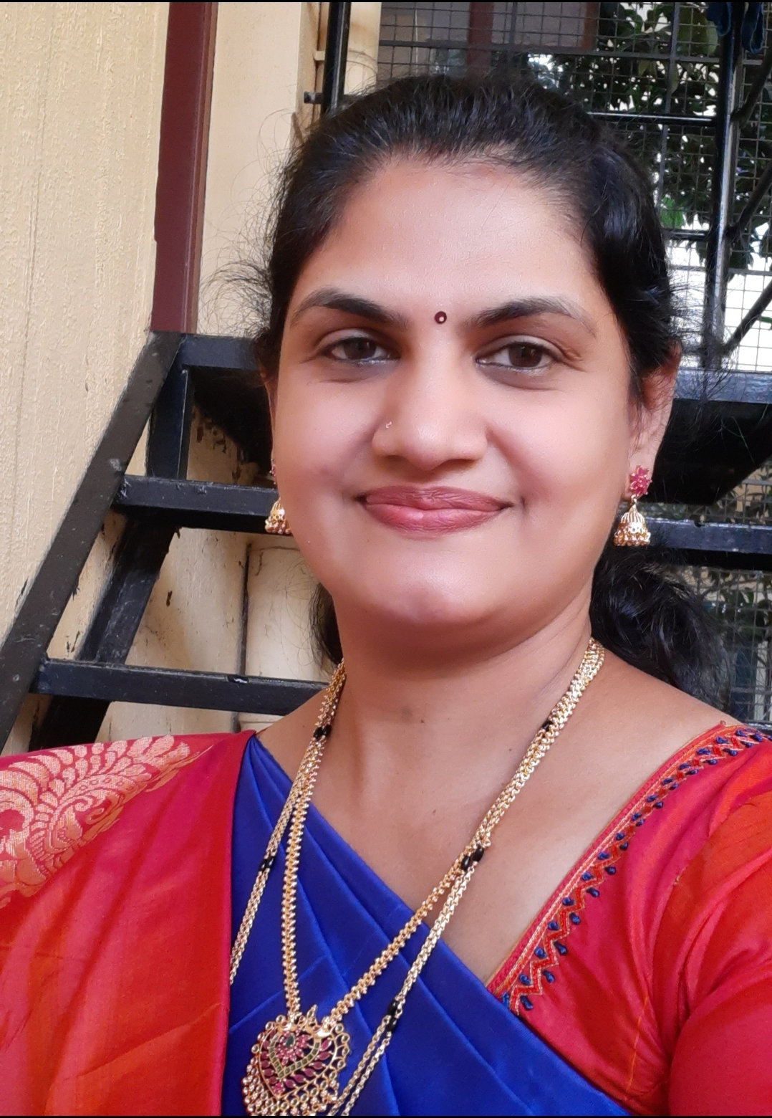

**“Yoga is bringing body, breath and mind together and also calming down the mind.”**

Shantala Bhat has completed Yoga Instructor Course in 2022. She came in touch with SYVK last year. She takes her classes as per the Ashtanga Yoga, VYASA, Jigani. She completely focuses on the correct postures as it has more side effects when done wrong. She gives personal attention to all the students while practicing asanas. She concentrates on the body and breath awareness while doing Asanas. She also gives significant time for calming down the mind by doing pranayama and Om meditation. She blends her soothing voice and brings the bhaava of bhakti into the yoga session by including melodious bhajans. She also conducts sessions for kids in the Annual SYVK summer camp. She is pursuing her Advanced Yoga Training Course to deepen her yoga journey and make her body flexible.

**Prathima D.S. (Trustee)**

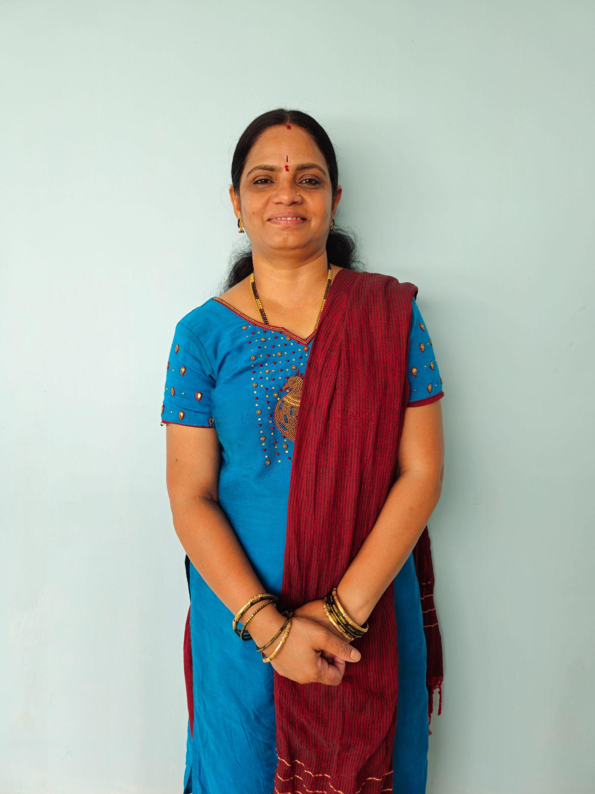

Starting her yoga career in 2016, she took it up as a commitment to reach out to those who are struggling with body pains and aches. Not before herself experiencing relief from severe neck and back pains because of her chores at home. She experimented yoga postures by joining Shree Yoga Vijnana Kendra between 2013 and 2016. Her happiness and relief is reflected in her own words, “After several months of consistent practice, all my body aches, anxiety and anger reduced.” Her strength lies in the therapeutic yoga practices aimed at reducing backache, diabetes, blood pressure and so on.

Her yoga certifications include: Yoga Instructor’s Course (YIC), Yoga Instructor for Diabetes Movement (YIDM), Advanced Yoga Training course (AYTC) and also completed Perinatal Yoga Course from S-VYASA.

**Meenakshi Sivaraman (Trustee)**

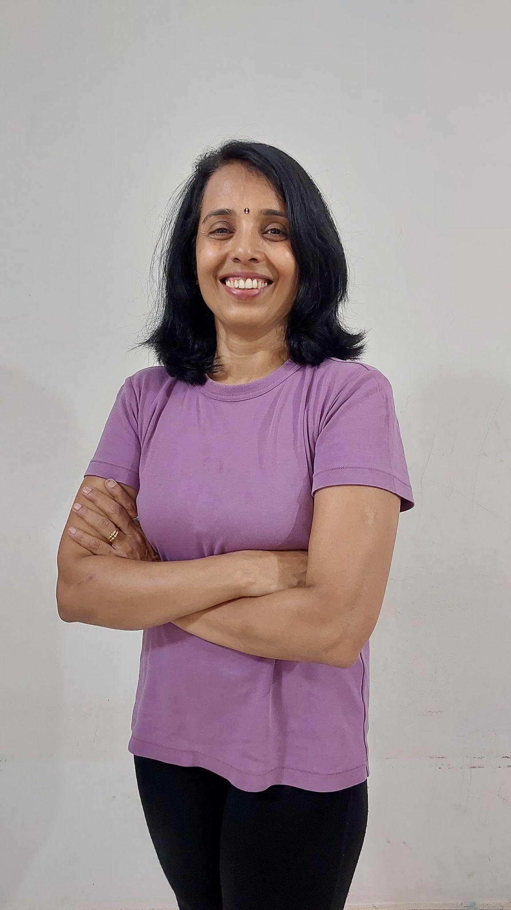

Yoga is a practice that connects the body, breath & mind.

Body- It uses physical postures.

Breath- breathing exercises

Mind-Meditation to improve overall health.

Full form of yoga:

"Your Objective Guidelines and Assessment”.

Yoga inspires me to have whole body experience of breath & movement.

I love connecting to myself & others through yoga & finding a sense of community.

Meenakshi has been teaching yoga since 2015. “Yoga has helped me to overcome the autoimmune disease. Since then, I have focused my yoga journey on improving health, happiness and calm through yoga asanas, pranayama and meditation.” she says. She takes multiple sessions throughout the day and guides her participants step by step into the final posture making sure that they follow the breath.

She is equally efficient with professionals, house wives, school and college students. She also conducts sessions for individuals requiring special attention in terms of specific asanas to cure themselves naturally from physically or medically limiting conditions. She also conducts prenatal yoga sessions.

Her accomplishments include: Yoga Instructor Course (YIC), Advanced Yoga Trainer, Supreme Master International Yogi Achiever Course (SMIYA), Other Certifications: Yoga Instructor for Diabetes Exercise (YIDM), Yoga Research Course

(CYS) Karnataka University and also won the Global Yoga Sanjeevini Award 2017 at the Global Title Championship held at Jawaharlal Navodaya Vidyalaya, Bangalore. She has also completed a referee course.

**Mamatha T G**

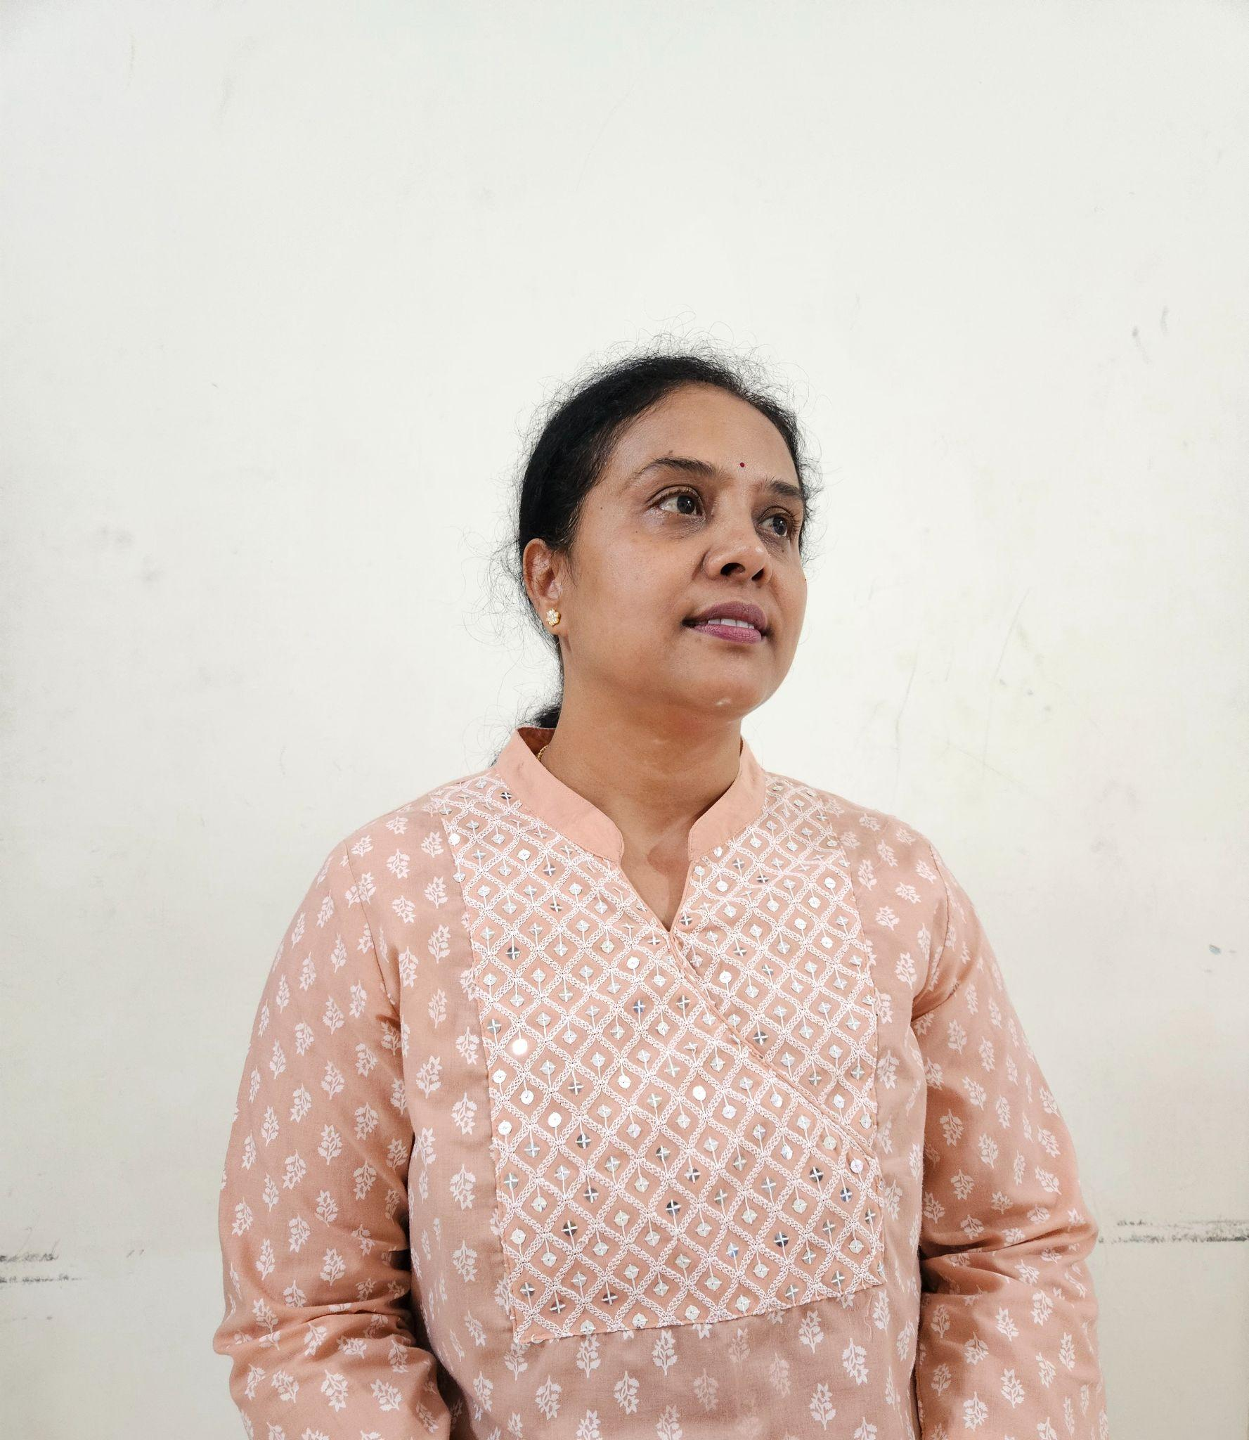

**“Yoga is the Way of life. It's an attempt to keep equilibrium in all aspects of life.”**

Mamatha has been with SYVK since 2012.. “SYVK has always been a welcoming, calm and peaceful center for me.” she reminisces. She attended the 10.30am Ladies batch from 2012 to 2014. The classes used to have guest Lectures by senior teachers on Mudra, pranayama, Rajayoga, about Trigunas , cleanliness and maintaining the health of ladies and so on.....

She has attended Rathasapthami celebration of 108 rounds of Surya Namaskar, Annual Day celebration which included guest lectures from Eminent persons and guests from S-Vyasa. She has been an active part of MADUMEHA MUKTA BHARATHA CAMPAIGN, witnessed the Guinness record of Shirshasana in front of VidhanaSoudha.

She started taking classes in January 2015.

She conducts sessions for people with back pain, diabetes, hypertension, thyroid issues and anxiety also. She guides them to regulate their daily living and helps them to control and maintain their paraments with Yoga practice. Her classes are interactive, providing them the opportunity to share their knowledge about their interests, their professions, hobbies etc.....

**Chaitanya G N**

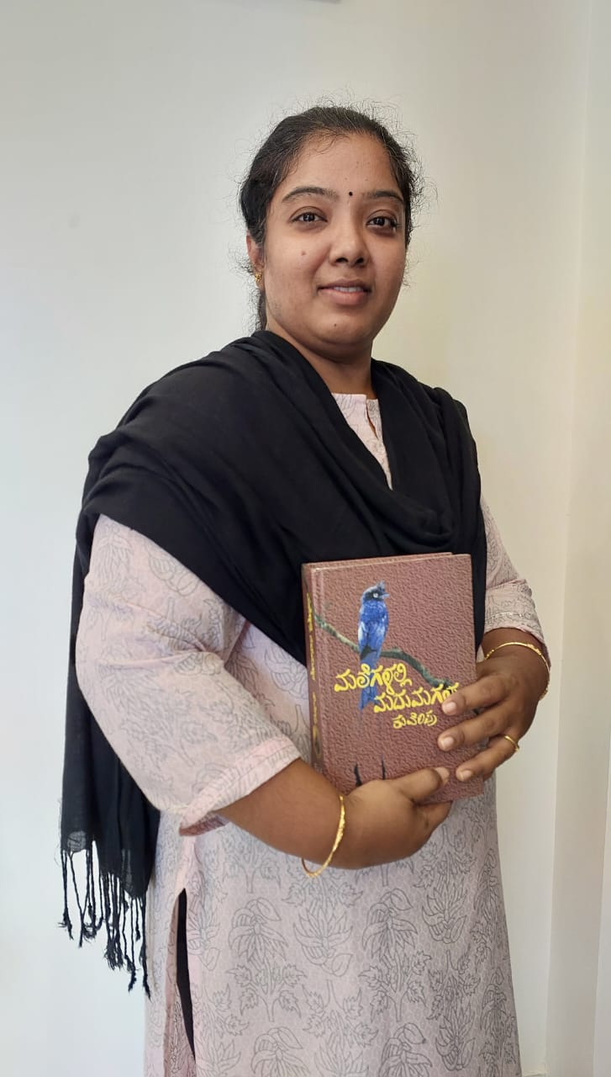

**“Yoga is the practice of connecting body, mind and breath”**

Chaitanya completed a decade of association with SYVK. Coming from a background of technical education, she has varied interests in kannada literature, reading and writing kannada articles, creating skits and directing them, stage performances, acting, making craft items apart from yoga. She has been a regular resource person for YIC sessions in practical sessions, where her fluent delivery of instructions makes it a comfortable journey for the young learners to get clarity in their own sessions. She likes organizing events as the anchor of the entire program and has executed many yoga events for SYVK. She takes active interest in the activities of SYVK and took lead in conducting the International Day of Yoga protocol at Rail Wheel Factory, Yelahanka in 2023. She is a cheerful person and brings in the same to her sessions.

**Subashri S**

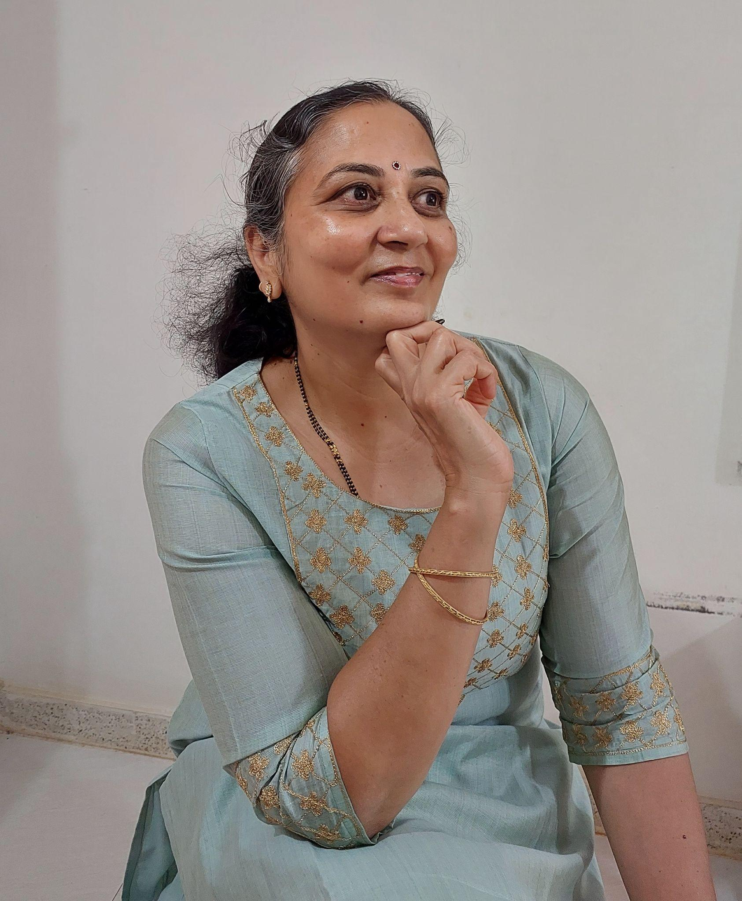

**“Yoga is a simple method to balance body and mind without extraordinary efforts or expenses”**

Starting her yoga journey during the challenging time of seeing her mother fighting cancer, Subashri completed her YIC in 2017. She has been teaching yoga since 2019, in both online as well as offline sessions. She is comfortable in personal interactions with students to guide her students of all ages as well as both male and female participants. Her sessions are innovative and packed with stretches for beginners, intermediate and senior practitioners. She has made steady progress in teaching yoga to others and gained the confidence of the students.

**Kashinath Gundad**

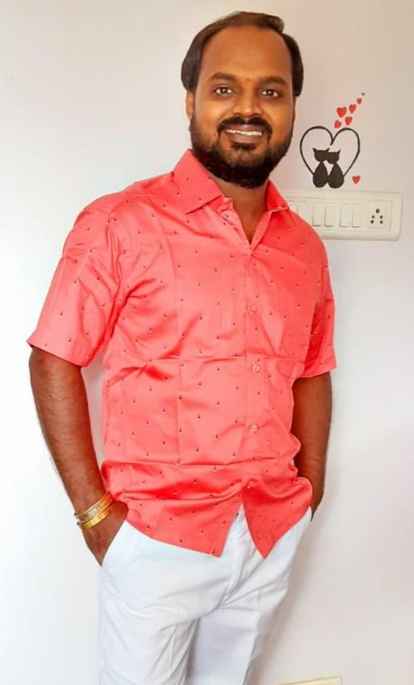

**“Do yoga, grow your life. No yoga, no life!”**

Kashinath has been practicing yoga since 2008, but started teaching in 2014. His yoga qualifications include Yoga Instructors Course, Advanced Yoga Training Course, Supreme Masters International Yoga Achiever Course, Yoga Referee Course. He wakes up in Braahma muhurtham and practices yoga everyday before resuming his worldly commitments. His effortless performance of advanced yoga asanas with a smiling face inspires the students to try them too.

**S Venkataraman**

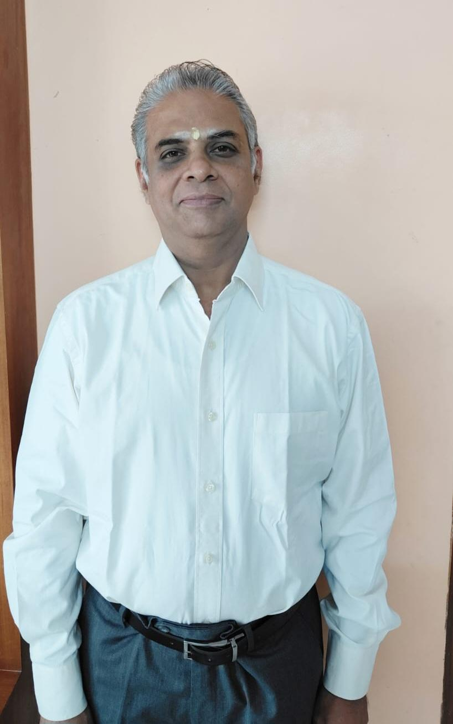

**Yoga enables controlling the mind, through which we achieve a better personality, clarity of thought to be better in daily life too ”**

Venkat as he is popularly known, has been a yoga practitioner since the 1990s though the formal certification happened in 2022. He has had a wide exposure to different schools of training like the Vivekananda Centre in Hyderabad, Sivananda School in Delhi and SYVK in Bengaluru. And this has helped him understand the nuances of yoga practice. At present, he is undergoing the Advanced Yoga Training Course. He feels happy and considers it as an achievement to be part of SYVK. His personal practice includes yoga asanas, pranayama as well as chakra healing.

**Gouri Hegde**

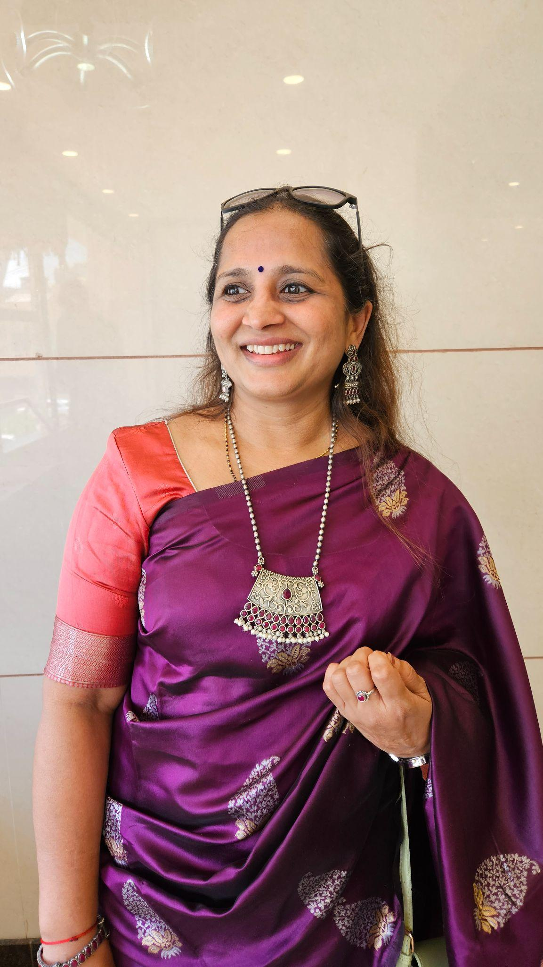

**“Yoga means yuj, to join the body, soul and the supreme soul”**

Kind hearted and gentle, blessed with a melodious voice, Gouri didi has a very clear Sanskrit diction and gives importance to correct pronunciation of shlokas and words. Her sessions on Srimad Bhagavad Gita Chanting reverberate with devotion and melody. She is a part of SYVK since its inception and has been instrumental in spreading the knowledge of yoga to many school children, in North Bangalore. She takes keen interest in gardening and is very creative not only in drawing and painting, but also in yoga session sequencing. With a keen eye on perfection in asana, she guides her students to work towards the same. Being closely associated with the founders of S-VYASA, she is a ready reckoner for any doubts related to asana and pranayama practices for students and teachers alike. She is very committed and sincere in all her activities and successfully conducts yoga based summer camps for children inculcating in them value for resources and love and respect for nature. She credits her healthy body and mind to her long years of yoga practice. She has a huge fan following of students for her sweet voice and correct pronunciation.

**Gopalakrishna Hegde**

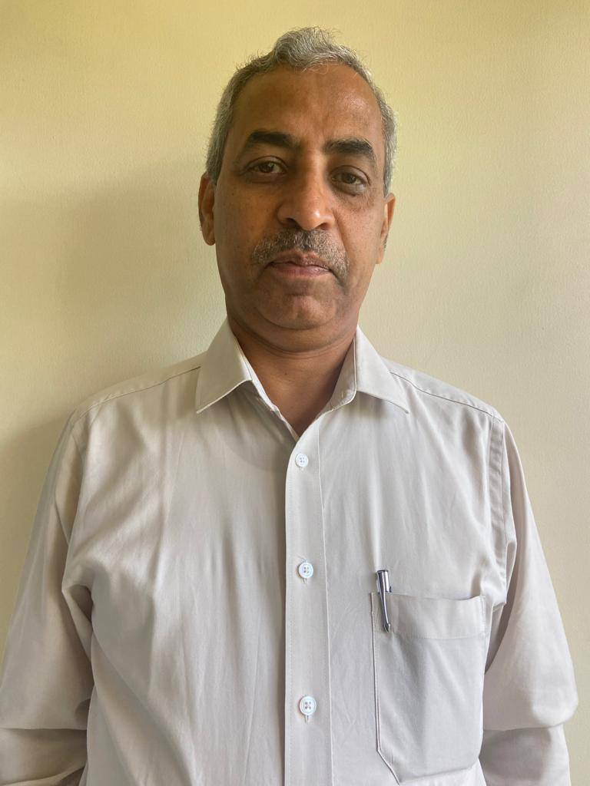

**“Yoga is a way of life.”**

Shri Gopalakrishna is the Founder President and Trustee of Shree Yoga Vijnana Kendra. He is a direct disciple of Padmashree Dr. H.R.Nagendra, the founder of S-VYASA. Being a passionate Horticulturist, he is equally well-versed in theoretical and practical aspects of Ashtanga yoga. He has been teaching-learning yogic knowledge since 2004. He regularly gives talks on topics related to yoga on All India Radio. (link to be given here)

He has been equally instrumental in bringing yoga to the corporate world in ISRO, ABB and other institutions. He is a very kind and gentle person and a very able leader who leads by example. Despite his busy schedule, he makes time for many philanthropic activities. And contributes his best in terms of finances as well as knowledge to whoever needs it. He is a quick decision maker and always ensures quick expedition of administrative duties by his team of faculty at SYVK. Apart from Yoga, he believes in the integrated approach to maintain health with Naturopathy, Ayurveda and other alternative therapies. He envisions an all encompassing therapy and scientific research center for yoga in a larger campus providing health and happiness for many more people at affordable rates for all. His “simple living and high thinking” make him a much sought after resource person for various platforms, online as well as offline sessions.

**Sadanand Guddad**

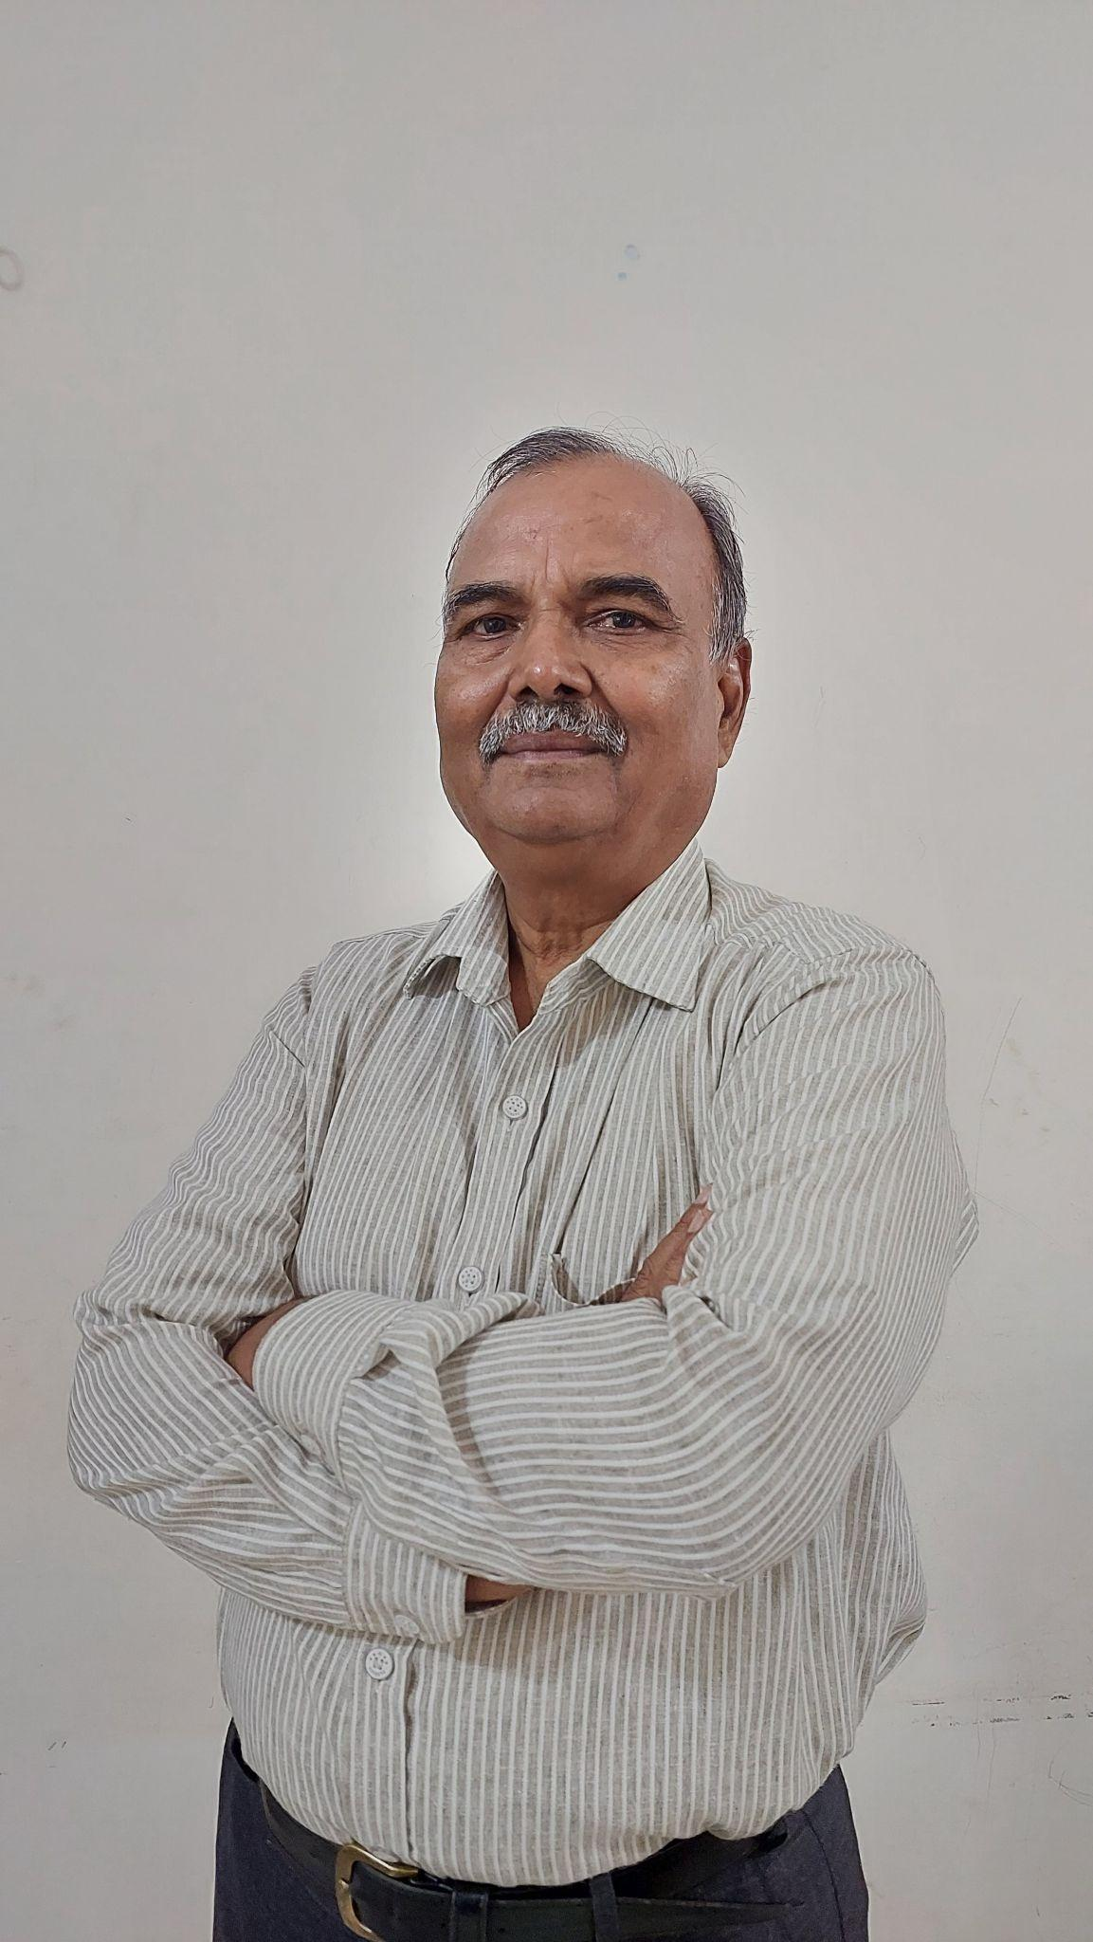

**“Yoga is a lifestyle which enables us to live a healthy,**

**happy and peaceful life.”**

Shri Sadanand Guddad is the Vice-President of SYVK and is more of a father-figure to all teachers and students alike. A retired Banker, he is one of the founding trustees and conducts an end-of-the-day calming down yoga session rightly called “Manaprashamana yoga”. He has been regularly teaching yoga since 2012, conducting regular classes for positive health, diabetic therapy and YIC theory classes. Coming from a beautiful family of well-bonded siblings and extended relatives, he treats each of the teachers and yoga participants as his own family and spreads care and affection among all. His success as a yoga therapist and yoga teacher lies in the fact that Many people (exact number not available) are leading diabetes-controlled lives, one lady is relieved of postnatal depression and now leading a successful life. Stress relief is

happening to most of the participants who were leading stressful before joining yoga. His guidance and consultation is sought after in many nearby yoga institutions. He takes active part in the conduct of the International Day of Yoga Celebration every year mobilizing more school and college students to the yogic way of life.

**Lalita Patawardhan**

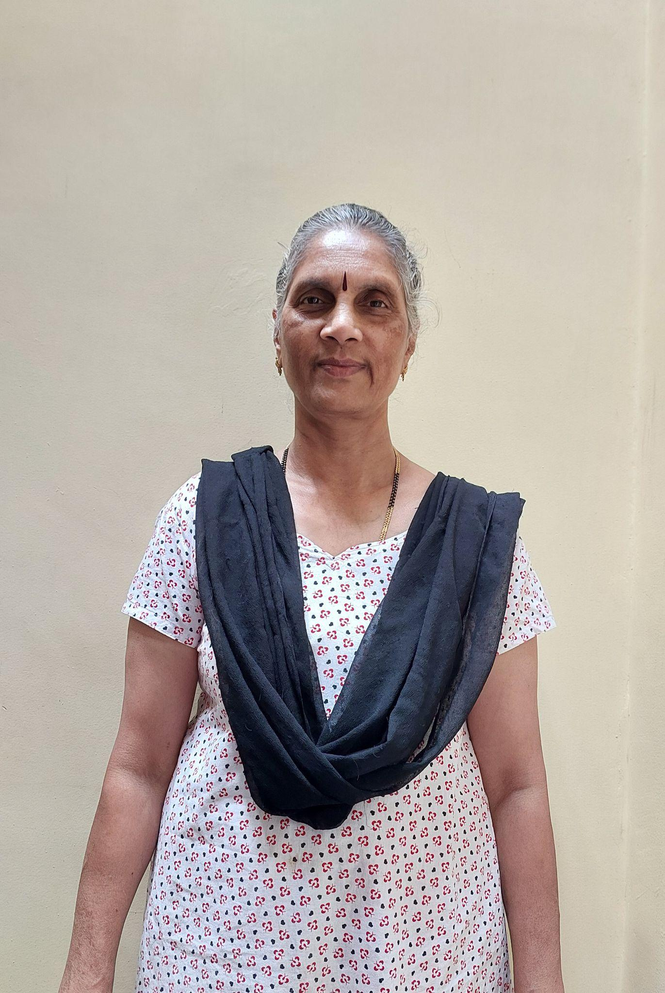

**“Living in harmony is yoga.”**

Smt Lalita, the senior-most lady teacher at SYVK, is the first to begin the day with her Braahma muhurtham yoga at 5 am. She is completely and wholeheartedly devoted to her work and brings in her native learning of sanskrit and biology into her sessions. Her commitment is reflected by the fact that she has been a regular teacher for her 5am batch since 2016, hardly taking any leave. She plans her vacation or other personal work such that she doesn't miss any of the weekday yoga sessions. She personally experiences complete involvement in the session that she conducts and says that the external world fails to exist for her during that duration. She is a constant learner by self-contemplation as well as by attending other expert sessions. She was felicitated on International Day of Yoga-2020 by Yoga Sangama, Yelahanka, Bengaluru. She is invited as a chief guest at schools and institutions for Yoga events. She is a popular resource person and conducts Sanskrit workshops on behalf of Sanskrita Bharati. A constant learner, she keeps her ears and eyes open to all possible avenues of seeking knowledge. She also conducts therapy sessions for backache, Diabetes and hypertension. She is presently doubling up as the YIC Coordinator and successfully handling the multiple demands of organizing sessions, getting tasks done from the YIC participants, arranging resource people, and ensuring a pleasant experience for the YICians.

**Sheetal Pillai**

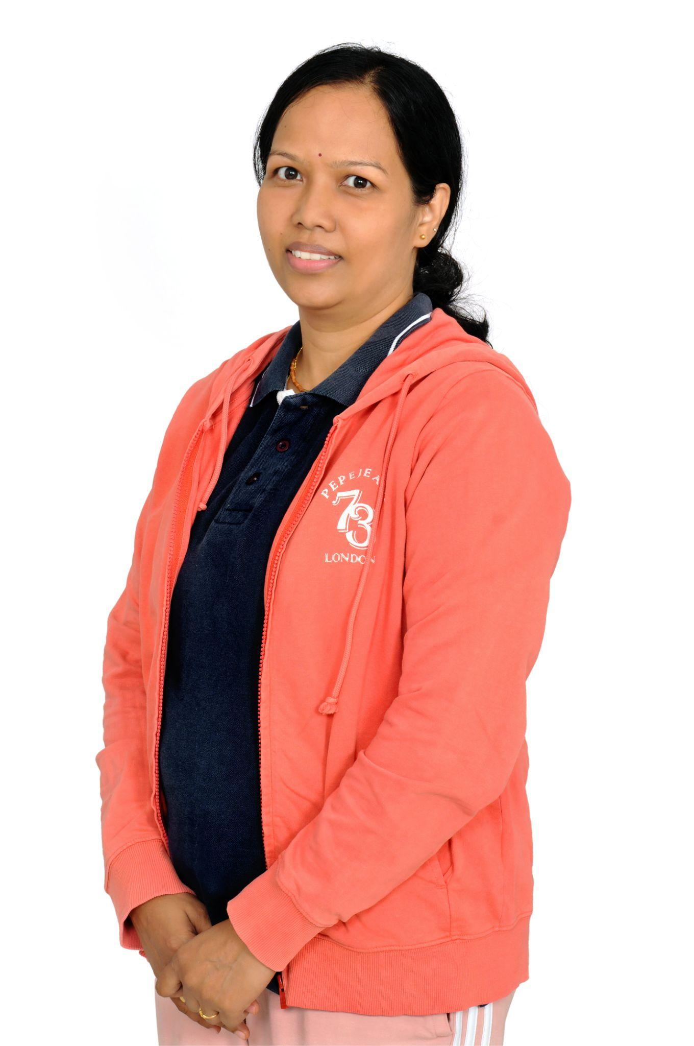

**“Yoga helps you experience a sense of control over emotions, develop a deep connection with Inner Self, and have a peaceful mind in a healthy body ”**

Sheetal started her yoga practice at Art of Living in 2016. After completing YIC, she immediately obtained her Master's degree in yoga in 2022 from S-VYASA and also holds other certifications likes Advanced Yoga training Course, Antenatal Yoga Teacher’s Training Course, Diploma in Ayurvedic Diet & Nutrition Course, Yoga Nidra Teachers Training Course and Yin Yoga Teachers Training Course . She also earned a Masters in Finance. After gaining several years of professional experience in the corporate world (IBM and other companies), she decided to make yoga her own career. She is a creative artist with great flair for making innovative yoga fliers for SYVK Social media. Despite the demanding role of mothering two young kids, Sheetal finds yoga as a beautiful time for recreation and rejuvenation. She believes that each of us is special, beautiful, and unique, due to differences in our movements and body structures, each practice is unique, and everyone can benefit from some form of yoga. She hopes to encourage and inspire others to explore and enjoy the physical, emotional, and spiritual benefits that yoga practice has to offer.

She regularly conducts therapeutic yoga sessions for various ailments including knee pain, hypertension, backache, weight loss, fibromyalgia, PCOD and so on. Her expertise in Chair yoga, Special relaxation techniques, Customized Meditation techniques, Yoga Nidra sessions, Yin yoga and Ashtanga yoga Vinyasa sessions make her a favorite teacher for her participants. She has been awarded the Achievement Citation from SYVK for Best Outstanding Contribution and Promotion of Yoga. She also conducted free sessions for many senior citizens on pranayama for Covid management. She specializes in diabetes management, yoga for cancer, yoga for kids and yoga for senior citizens.

**Dr.B.K.Chandrashekhar**

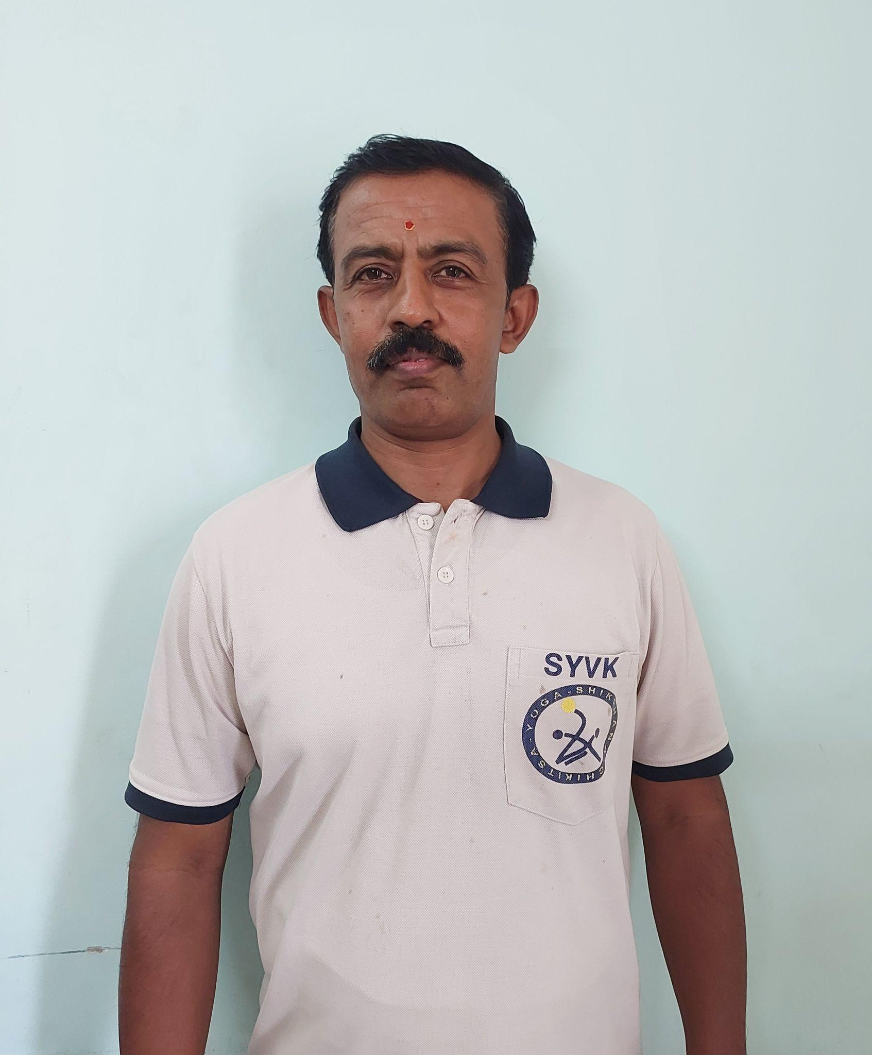

**“Yoga is an ocean. Its knowledge is wide and expansive.”**

Dr. Chandrashekhar specializes in conducting yoga therapy for various ailments. Some of them are Asthma, Obesity, Headache, Nervousness. He actively specializes in teaching fitness yoga, Advanced yoga, Smiya yoga, Advance power yoga, Kriya yoga, Artistic yoga, Pair yoga and Rhythmic yoga. He is known to motivate his students by counselling them, demonstrations and motivational speeches. He is an international yoga referee.

· Practicing yoga since 1986.

· Teaching yoga since 1990.

After receiving his Bachelor’s degree, he completed Certificate Course in Yoga Studies degree (CYS) from Karnataka University, and felicitated with honorary doctorate from virtual University Chennai. Having faced severe health disturbances as a child, yoga gave a new lease of life to Dr. Chandrashekhar and since then, he has passionately been involved in spreading this ancient wisdom equally by teaching and personally living yoga .

Having started his yoga journey at the age of 13, when most kids are busy playing and day dreaming, the young Chandrashekhar met and sought the guidance of a few Yoga Gurus and doctors to resolve problems and pains of people. Based on this and his own natural insightful learning, he successfully treated people after thorough research. After getting very good results, he began teaching yoga at many yoga centres, schools, colleges like Gitam University, Rai University, CYS college, Jawahara Navodaya Vidyalaya, Chrysalis High etc.. he conducts yoga programmes, yoga seminars, workshops, camps, competitions all over the world.

He was felicitated by the Pondicherry Government as an International Yoga Champion of Champions and International Jury by Government of Karnataka.

Awards received:

· Department of Ayush Bharat yoga shrestha by Uluberie college, Howrah- West Bengal,

· Yogacharya Award by Karnataka south zone yoga foundation,

· Bangalore University hatrick Gold medallist in yoga event,

· DD-1 TV channel yoga anchor and programmer,

· Karnataka yoga kumar, Bangalore yoga kumar,

· Bharath yoga siri Awardee,

· Lifetime yoga Achievement Award from Thailand,

· Best Jury Award from Malaysia,

· many Guinness records and many more rewards.

Yoga related certificates

· Advanced Yoga Training course (AYTC)

· Supreme Master International Yogi Achiever course (SMIYA)

· Yoga Pravesha Certificate course

· Yoga Sadhaka Certificate course

· Yoga Praveena Certificate course

· Yoga Shree Certificate course

· Yoga Kala Ratna Certificate course’s Founder & Designer

· Certificate course in yoga studies (CYS) – Karnataka University.

· Yoga Instructor course (YIC) – Indian school of Yoga.

· Diploma in Yoga Therapy (DYT) – Indian school of yoga

· International Referee course (IRC) – Government of Karnataka, Ayush.

· Karnataka yoga Association Referee (KYA) – Karnataka Yoga Association.

Mamatha V

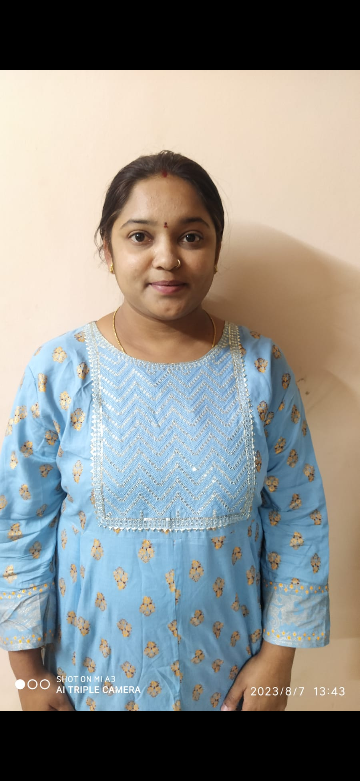

**“Mind , body and breath control at a time is yoga.”**

Mamatha is a software engineer by profession and a yoga practitioner by desire.

**Sharmila Mhashalkar**

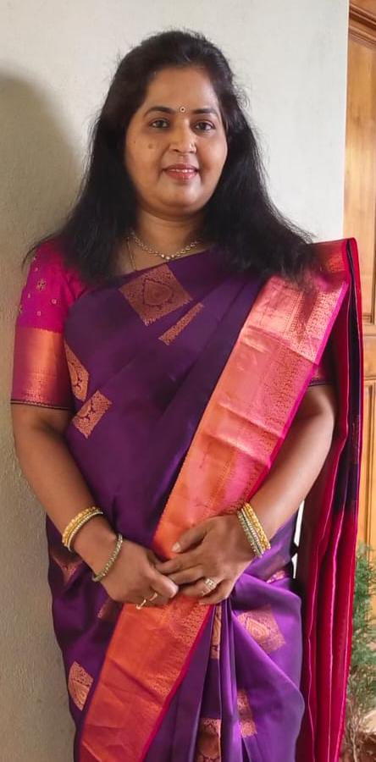

**“Yoga needs to be practiced and experienced for liberation.”**

Sharmila has been associated with SYVK from the year 2015. She has a good hold on Patanjali Yoga Sutra and has been teaching the same. She also conducts therapies for various yoga practitioners. She has also completed the Advanced yoga Training Course and also conducts classes for many yogis for the same. She teaches Bhagvad Geeta to her students. To put all together, She has been practicing and preaching both "Yoga Marga" and "Bhakti Marga" to her students.

Her expertise lies in treating some of the most common but life risking diseases. She has expertise in curing issues like Diabetes, Hypertension, PCOD and PCOS, obesity, High cholesterol and backache. She undertakes need based yoga therapy for prenatal and postnatal care.

**Anuradha Belamkar**

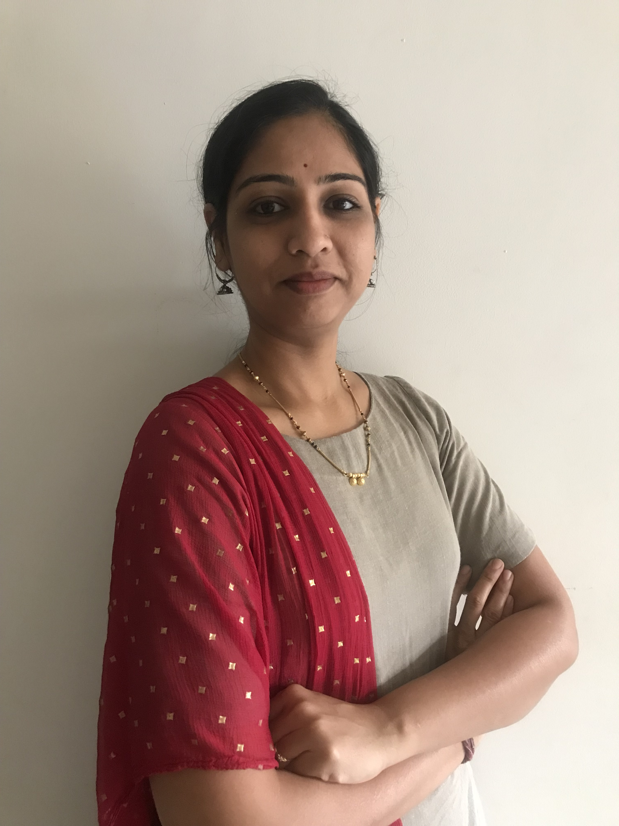

**“Yoga is all about self discipline, handling emotions and breathing awareness. Yoga teaches us to live life with harmony. It builds a positive attitude with physical strength by performing asanas and mental strength by Bhakti Yoga”.**

As a long term student, Anuradha tries to learn and achieve perfect postures as per her strength. Hence, when she conducts sessions, her participants also are motivated to try and experiment with their postures and reach maximum perfection. She focuses on asanas in detail giving time to experience the physical details and then allowing an inward journey into the breath and mind.

Having completed her YIC in 2022, she is hardworking and dedicated in her approach.

**Ashwini N**

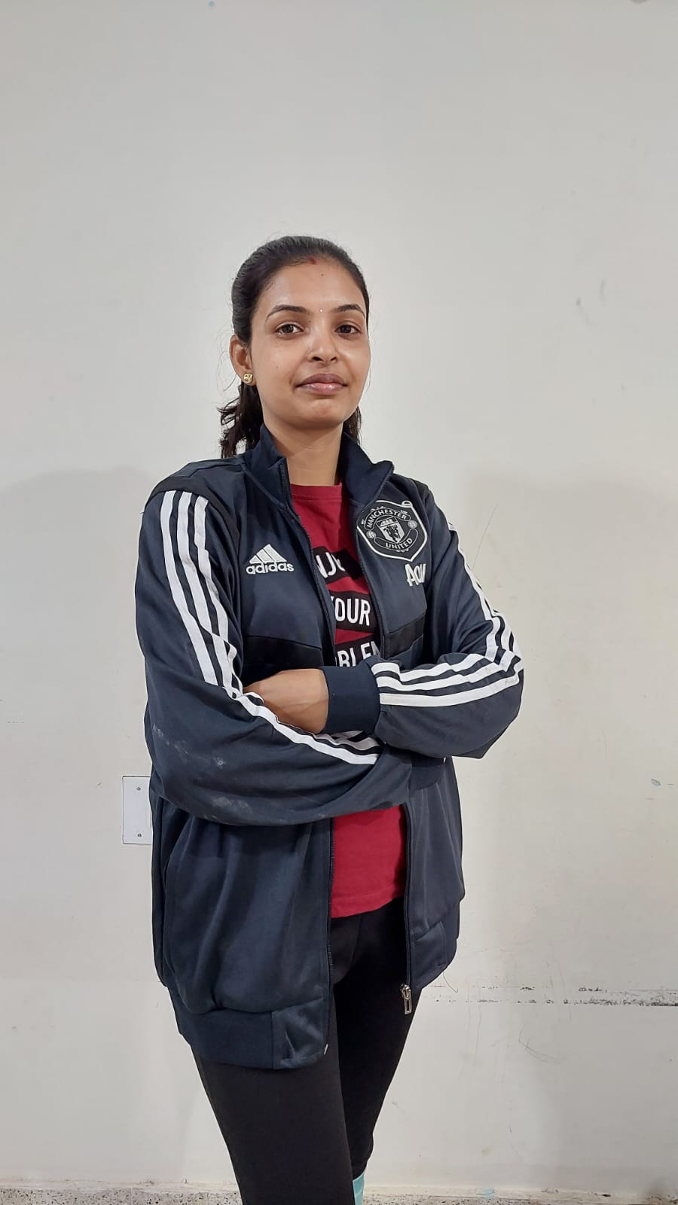

**“Yoga is Flexible body, peaceful mind and stable breath.”**

Ashwini has been conducting yoga classes since 2020. With her petite figure, she balances flexibility and strength in her dynamic power-packed yoga sessions. She conducts two batches everyday and her expertise lies in effortless easy stretches which give a lot of muscle strength in the long run. As an expert demonstrator, she is a favorite choice for International Day of Yoga programs and events in schools and colleges. The participants in her batch experience increased flexibility, weight loss, concentration and determination throughout their daily routine. Testimonials about her sessions give us a glimpse of manifold benefits for participants in her sessions:

“I have been practicing yoga for the past 9 months. I joined yoga to reduce weight since I was facing a lot of difficulty in day to day activities. After I started yoga I reduced about 11 kg till now and with this I am very much flexible and active in my daily routines.”

**Rajalakshmi N**

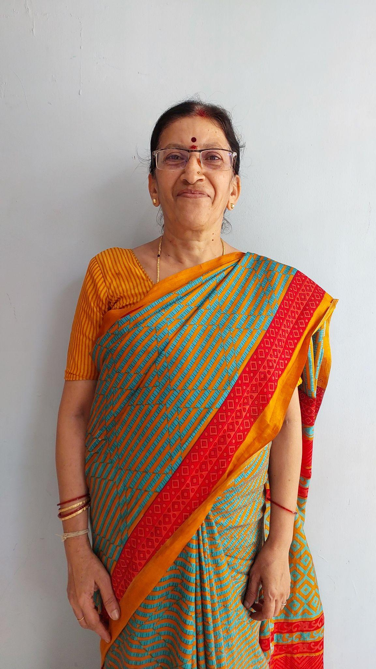

**“Yoga is a spiritual discipline.”**

Just the presence of Smt Rajalakshmi is enough to make anybody feel calm and relaxed. Since 2015, she has been conducting yoga classes and her personal practice goes back to her early childhood. Having been practicing for so many years, she is very very convinced about the benefits of yoga for all and is passionate about her teaching. She wants to reach as many people as possible through her yoga sessions. She credits her flexible body and calm mind to her disciplined yoga routine. Maintaining a fine balance between her elderly in-laws and a young grandchild, she also is equally passionate about art and craft. She takes active interest in our kids’ summer camp every year.

**Jayashree Murali**

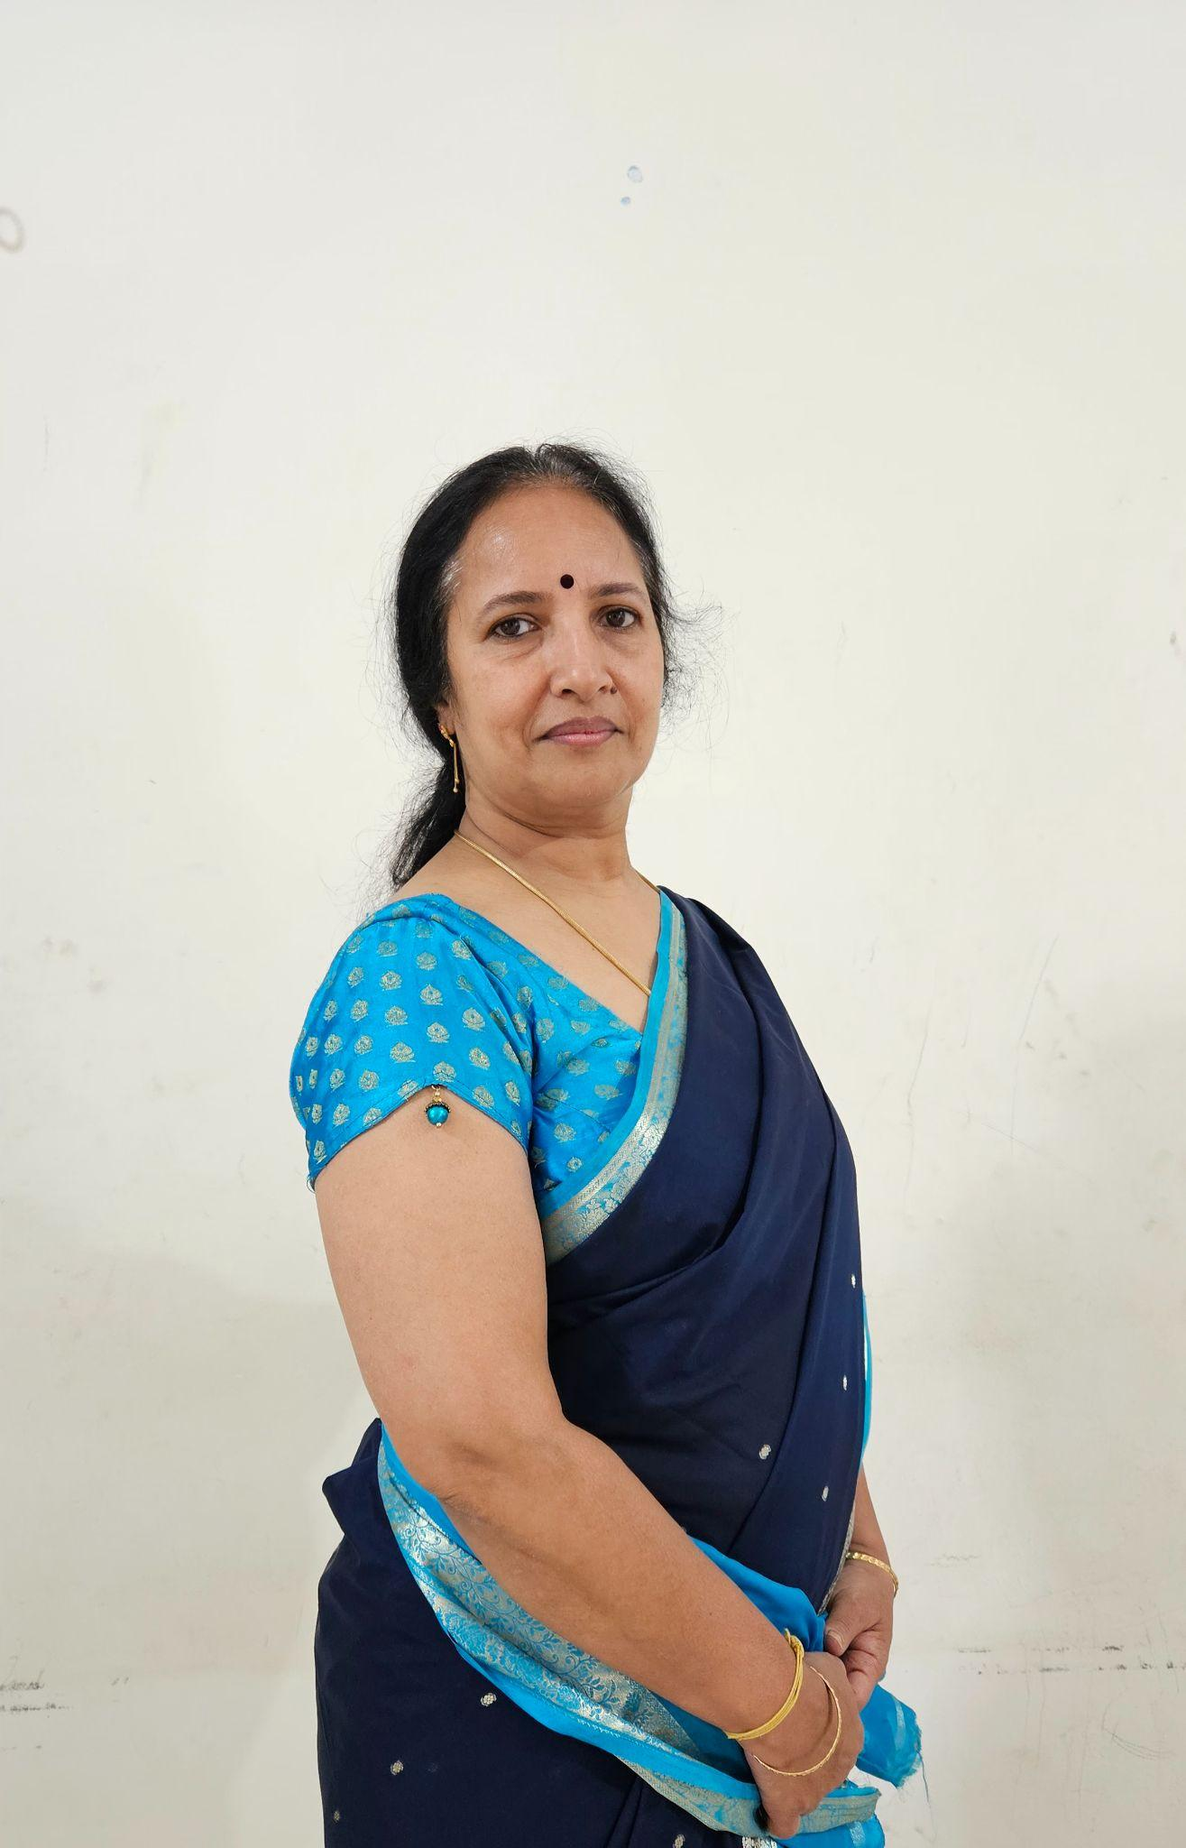

**“Yoga is a way of life.”**

Jayashree has completed her M.Sc in yoga after her YIC and Advanced Yoga Training Course. Her expertise is Cyclic Meditation, an advanced technique to reduce stress and considerably improve the quality of life. She has been a teacher since 2015. She teaches bhajans, Srimad Bhagawad Gita chanting and also is a faculty for the YIC conducted at SYVK. She conducts therapy sessions as per the requirements of the participant.

**Vishal S H**

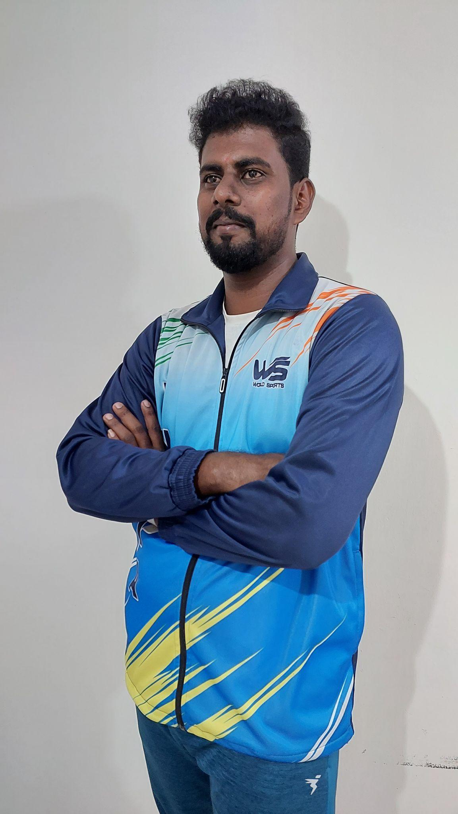

Vishal, true to the advanced power yoga sessions that he takes, is a strong youngster with an ability to connect deeper with his participants through his dynamic practices. He combines the natural skills that he has with the rich experience of his teaching at various schools to get the desired results, whether in rhythmic yoga, artistic yoga or yogic formations. He has been a yoga teacher at various schools and presently is a successful yoga teacher at Chrysalis High Marq, 5H School, Mathikere, and KRLS Patel Rama Reddy English High School, Domlur. He is also a certified Yoga Referee. He has bagged several awards in yoga competitions at district and state levels. His name features in the Guinness Book of world Records, 2017 for Shirsasana in front of Vidhanasouda. He conducts personality development sessions for children, guides them to participate in yoga exams. He has trained lakhs of students for rhythmic and artistic yoga. He conducts special sessions catering to specific conditions/ailments among children.

**Ashwini Tapasvi Sahane**

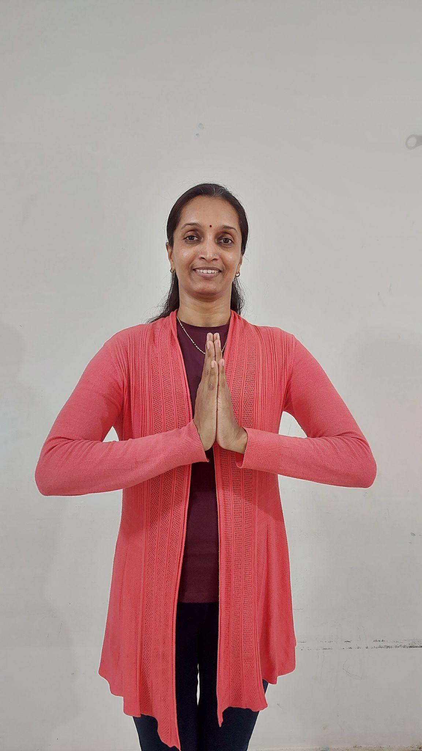

**“Yoga is a way of life”**

Wanting to become a pilot and maneuver flights in air, Ashwini now has opened her arms to guide people’s health habits on land to rediscover their happiness. She has been a very active teacher since 2017. Her technical knowledge makes her equally proficient in online as well as offline sessions. She is a trained yoga instructor for Diabetes Mellitus. Her thirst to perfect asanas, led her to the Advanced Yoga Training Course in 2019. In pursuit to deepen her yoga knowledge, she has completed her M.Sc in yoga from S-VYASA, where she submitted a thesis on IAYT(Integrated Approach for Yoga Therapy) for hypertension.

She is acclaimed as a yoga therapist for diabetes, thyroid disorders, hypertension, Asthma etc. She conducts regular Meditation sessions and cleansing purificatory practices called kriyas.

**Vani A Hegde**

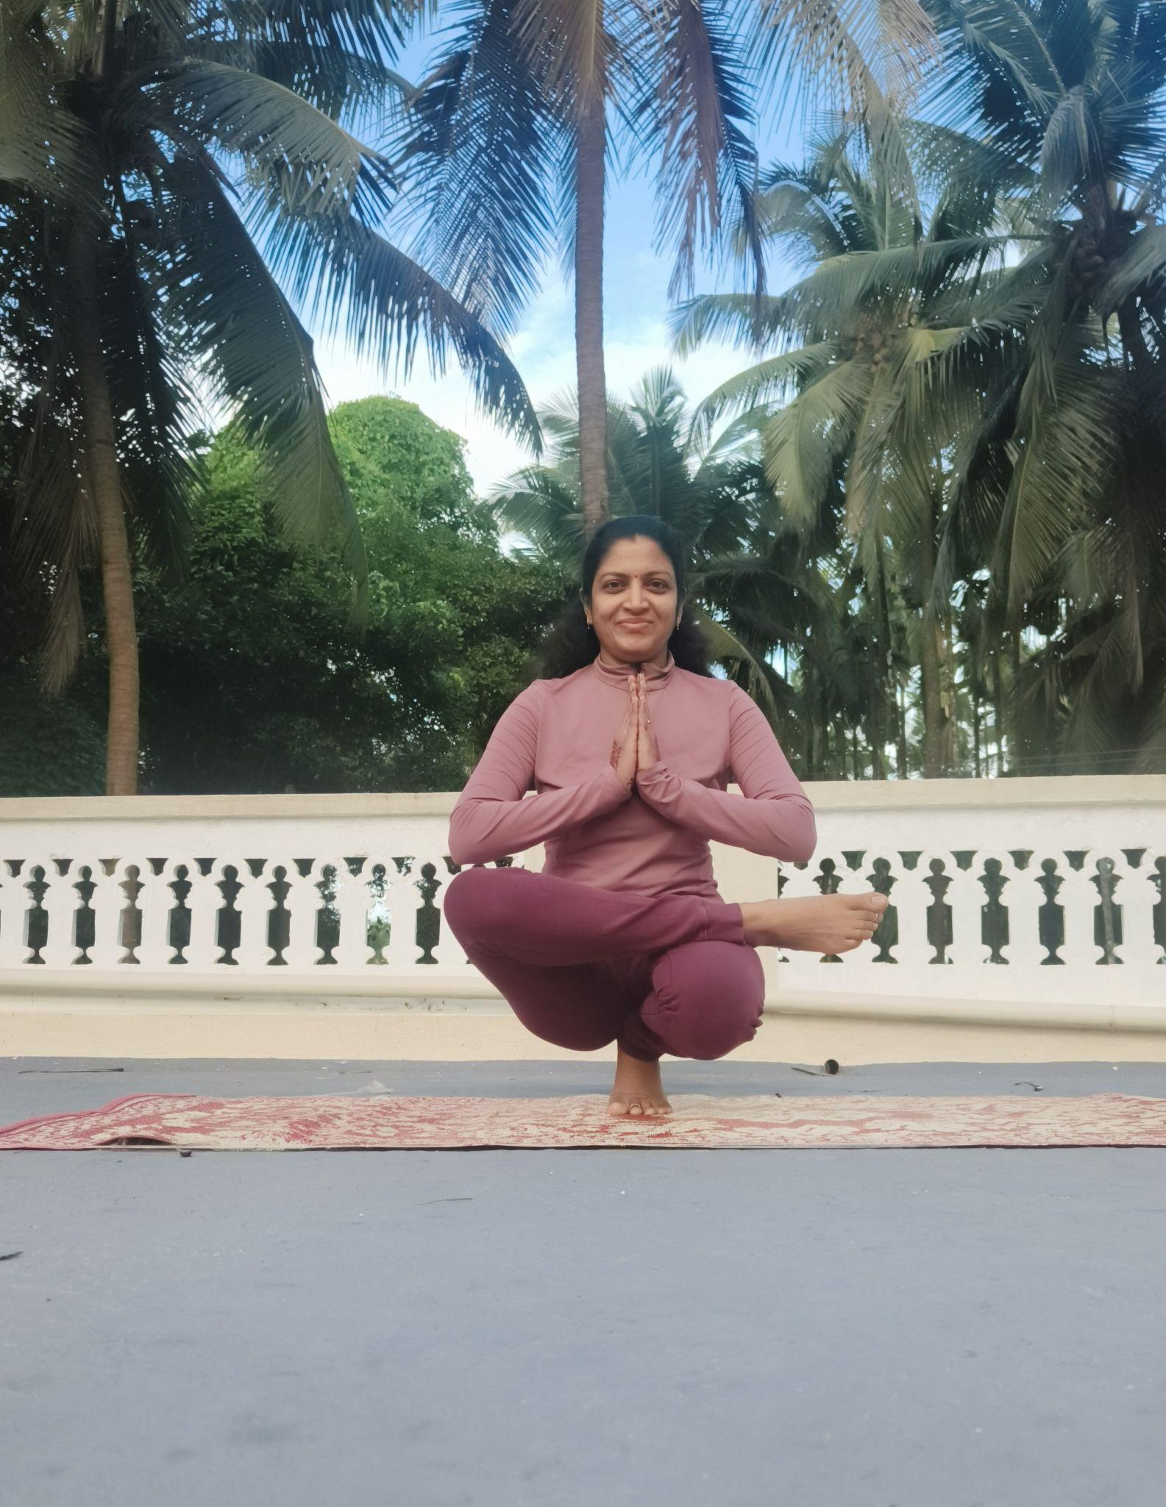

**“Yoga is Dinacharya, essential spiritual discipline,**

**if missed, will remind its absence leaving us guilty”**

Vani Hege hails from Dharwad. She has been practicing yoga from 10 years. She started her yoga journey in Dharwad when she was 35 years young. Vani has been with SYVK from past 5 years. Her educational qualifications include Bsc in statistics . She is also pursuing Msc in Yoga. Her thesis topic is Effect of Laughter Yoga and Nadanusandhana pranayama on elderly citizens in improving the quality of life and quality of sleep. Nadanusandhana is about creating vibrations in the body which resonate in the body to remove toxins from the body(Annamaya kosha) and thoughts from the Mind (Jyanamaya kosha) to achieve the ultimate Samadhi state and union with the Brahman.

Vani’s classes include students from age 10 to 65 years. Each class is planned to make sure all the students are engaged throughout the class. She strives to make her students achieve their dream poses along with fun activities, 2 min challenges, Bhagavad Gita recitation, laughter yoga and many more.

Punctuality, commitment and time management are the key takeaways from her classes.

**Anitha Hegde**

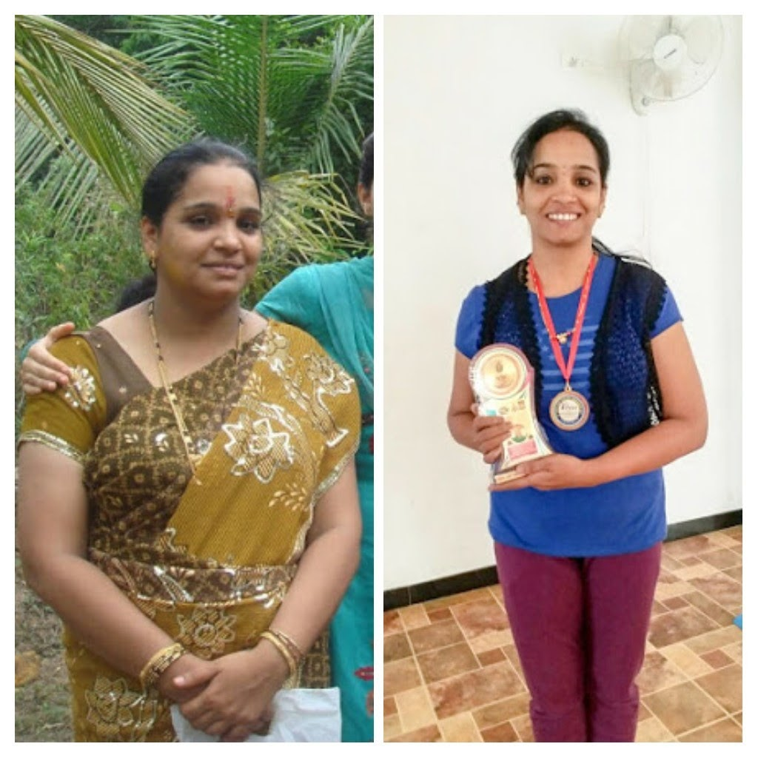

**“Yoga is a systematic way of doing the body movements with breathing.”**

Anitha has earned the title of Trivikramasana Anita, due to her perfect balance, impeccable alignment, attention to meticulous details in the asana and incredible stretches. She is an advanced yoga trainer and practitioner herself spending almost 4 to 5 hours of personal practice other than conducting training sessions for her students. This easily makes her a national level gold medalist in many of the competitions she participates in. Her name is in Guinness Book of World Records for Longest holding of Shirshasana for yoga practitioners held in the year 2017 at Vidhana Soudha. She is an Yogarjuna Awardee in 2016 and Yoga Praveena in 2017. She also conducts group/personal therapy sessions for prenatal yoga, diabetes, backache, high blood pressure, thyroid and other hormonal disorders to name a few of them.

She is hardworking, dedicated and sincere in her approach and expects these same standards from her students. She is a name to reckon for at ISRO yoga sessions and many other corporate sector and educational institutions. Her Lecture-demo sessions have been very successful not only in Bangalore, but in other districts in Karnataka too. She has completed M.Sc Yoga apart from Advanced Yoga training Course, Supreme Masters International Yoga Achiever’s Course, Yoga Referee Course and Yoga Instructor in Diabetes Mellitus, all affiliated to VYASA, Jigani, Bangalore.

**Balaka Chatterjee**

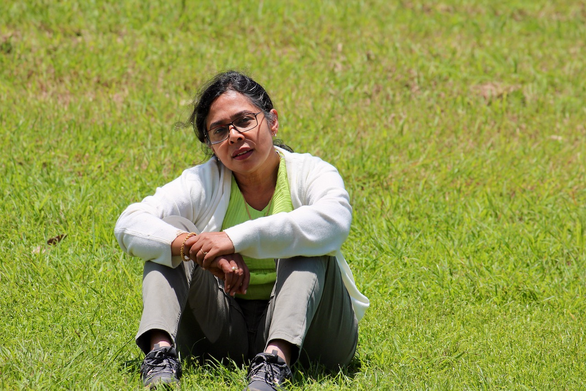

**“Yoga is a space where you are aware of your body and thoughts and are willing to tune it for higher potentials”**

Balaka has been with Shree Yoga Vigyana Kendra from its early days and has been an integral contributor to its success and prosperity. In 2013, she completed her Yoga Instructor's Course in the second batch from SYVK.

By profession, Balaka is a cost accountant who has previously worked with many private companies and international organizations.

In 2021, she obtained her Master's degree in Yoga and now uses her deep knowledge and insightful understanding in therapeutic yoga treatment with respect to the gut and related systems. Her deep relaxation and advanced techniques classes are thoroughly enjoyed by all participants.

Balaka was the YIC Coordinator for 2023. In her batch, she inspired her students to produce mini research-based projects as part of their YIC submissions. Her earnest passion towards teaching her students all that she can and making them the best versions of themselves makes her a very special yoga mentor.. Her sessions come from a deep understanding of the subject matter and with a lot of take away messages conveyed with the same amount of motherly love and compassion.

**Sukanya Subramanya**

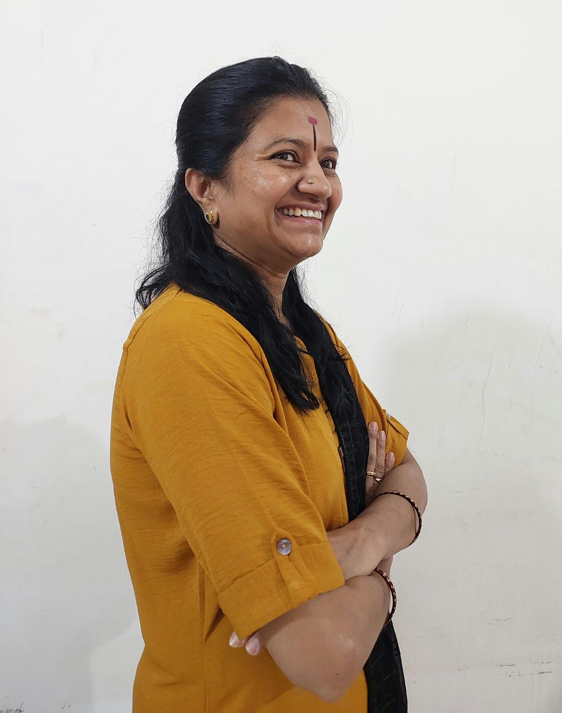

**“Yoga is a spiritual way of disciplining life.”**

Sukanya has been part of SYVK since 2013. Experiencing the life changing transformations through yoga herself as a student, she realized her passion towards health and happiness and expanded herself to reach out to more such people who needed yogic care. After completing her Yoga Instructors Course in 2017, she also immediately equipped herself as a Yoga Instructor for Diabetes Mellitus. She intensified her yoga journey to complete Advanced Yoga Training Course all from VYASA, Jigani, Bengaluru and then capped it with the Supreme Master International Yoga Achiever Course.

Her success story in yoga is an inspiration for all who know her. She is a generous donor to SYVK and has sponsored the YIC program for many needy and deserving candidates. Apart from this, her expertise in dealing with the senior citizens makes her a reliable resource for “Chair yoga with the elderly” and she ensures a good bonding within her participants where each of them encourages the other to perfect the asanas. She regularly conducts yoga and laughter sessions for girls at Sri Dayananda Saraswati Ashram, Attur, Bengaluru. The average age of her therapy batch is 60 years young. She believes that variety in asana practice helps the body see more benefits in a shorter duration. Her innovative guided meditation sessions are very well received. Krida yoga and laughter yoga is her speciality. A down to earth personality with a beautiful smile always on her face makes her easily accessible to people of all ages, kids and adults alike.

Consultants on our panel

Dr. Archana Hegde

Dr. Niranjan Hegde

Dr. Ishita Joshi

Sherlie Agrawal

We need the details from them also. I had already sent details as received from Sherlie. Please confirm.

Reviews:

Om Sri Gurubhyo Namah

SYVK is one of the best yoga institutes. It is known for its authenticity and traditional approach to YOGA. The institute offers a wide range of yoga programs and courses catering to all levels from beginners to advanced practitioners. The institute fosters personal growth and well-being. The faculty members are knowledgeable and experienced, who ensure high-quality instruction, making it an excellent choice for anyone seeking to deepen their yoga practice. Chaitra SR

One of the best yoga instructors courses , and yoga centre , therapy classes for diabetes, Sunday advance course . I have been going to this yoga centre since last June and it has worked wonders . My thyroid has come to control . And my body is toned and I am very happy with all the teachers.

Kavya Sunandaraj

My 4 year old daughter attended a 10 day summer camp, Bala Vikasa Shibira at SYVK. As parents we were doubtful if she would be interested to attend the program but surprisingly she was very eager to go to class everyday and enjoyed it. Teachers are extremely good and made the class very interesting for the kids with stories and activities and funtime along with yoga. Laughter yoga for parents, visit to nursery, the wonderful valedictory ceremony of all kids were some of the additional things parents could be a part of. The discipline and values they teach at the institute is much needed for everyone and we are extremely happy that our daughter got this exposure at such an early age. One of the best places we have at yelahanka and I strongly recommend this place for all. Thanks to all the lovely teachers at SYVK for the love and dedication. Sripriya

Quality of teaching is good.

Teachers are very approachable.

Commendable teaching staff.

Friendly environment. Shree

I first got introduced to SYVK when I joined their free 1 week course for seniors. The patience, professionalism and dedication with which the instructors, Vani & Sheetal, conducted the course, taking into account our various limitations, was very good. Feeling good, energised and motivated after a week of Yoga ( Warm up exercises, Relaxation techniques, Chair & Regular Surya Namaskaars, Yoga Asanas, Pranayams) I joined SYVK's 1 month free Stop Diabetes Movement Online Course. Also encouraged my friends from Mumbai, Delhi, Canada & USA to join the course.

Now in the 3rd week of the course we have all learned so much from the wonderful team of enthusiatic instructors, Vani, Sheetal, Sharath & Amruth who take turns to demonstrate, closely monitor us and correct us for right postures and movements.

Special mention:

1. Very clear communication of instructions

2. Detailed explanation of the science and reasoning behind the breathing , relaxation techniques, mudras.

3. Explaining the health benefits of every warm up exercise and Asana.

4. Forwarding on What's App, notes on what is being taught in the classes.

5. Encouraging feedback and interaction from participants.

6. Gradually increasing intensity of exercises and gently motivating us to perform better.

All in all it has been a great experience ( doing yoga with personal instructors in the comfort of my home) and I look forward each day for the class. I feel so much more energised and am able to appreciate the usefulness of Yoga in maintaining a healthy mind and body.

Thank you team SYVK. Ranjani

A friend introduced me to SYVK. In the past, I did not enjoy yoga classes much and was never consistent. But this time, it's been a pleasantly different experience. I enjoy the asana's and the variations which enable me to push myself, teacher ensures that it does not become monotonous, she touches both physical and mental aspects, and also caters to individual needs while making us comfortable. I am experiencing a positive change in me both physically and mentally and and look forward to every session. A big thank you to my teacher and SYVK.

**Courses Conducted at SYVK**

# 300 hours – Yoga Instructor’s Course (YIC)

**Introduction:-**

YIC course has been specially designed so that a person feels comfortable and sufficiently knowledgeable to be able to teach Yoga, in a positive non harmful manner, which imbibes ancient knowledge of India. YIC, a professional yoga instructor training program, consists of holistic knowledge of living and not merely yoga postures. SYVK has been offering this course since 2013 with great benefits. The holistic way to prevent diseases, promote positive health and bring harmony and peace in the society. Credit goes to VYASA, Bangalore Yoga University for all the efforts made to bring an idea of regulation over learning and teaching Yoga.

**Curriculum:-**

###### The Yoga Instructor’s course consists of the following subjects which transform the students' ability to learn yoga and provides the platform to teach the yoga individually.

###### **Theory:**

###### Introduction to yoga and its’ streams (2 credits)

###### Life and Message of Spiritual Masters and Applications of Yoga (2 credits)

###### **Practical:**

###### Asanas & Kriyas (2 credits)

###### Pranayama & Meditations (2 credits)

###### Teaching techniques & Karma yoga (2 credits)

###### Yogic games / Happy assembly and report (2 credits)

**Personality Development:-**

Yoga Instructors’ Course at SYVK helps an individual to shape his/her personality. Personality is the complex of mental characteristics that makes an individual unique from other people. It includes all the patterns of thoughts and emotions that cause us to do and say things in particular ways. At a basic level, personality is expressed through our temperament or emotions. The YIC at SYVK provides the platform to build up the personality.

**Teaching Methodology:-**

###### Powerpoint presentation

###### Learning and applying eight steps method to teach

###### Demonstration

###### Group discussion

###### Group Practice

###### Library facility to all

###### Report & Worksheet writing and presentation

###### One to one discussion

###### Lectures

###### Review classes

**Syllabus For YIC:-**

* Introduction to Yoga and Yogic practices
* Introduction to Four Streams of Yoga Introduction to Hatha Yoga Introduction to Patanjali Yoga Sutras
  + Karma yoga,
  + Bhakti Yoga,
  + Raja Yoga,
  + Jnana Yoga
* Bhagavad Gita
* Introduction to human systems,
* Yoga and health,
* Yoga for wellness- prevention and promotion of positive health,
* Yoga and stress management,
* Yogic Diet
* Life and Message of Spiritual Masters & Indian Culture,
* Kriyā(Cleansing),
* Āsana (Poster),
* Prāṇāyāma (Breathing),
* Dhyāna (Meditation)– Practice & Presentation
* Kīrtana (emotion culture),
* Krīḍa Yoga (Games)

###### **Evaluation:** There will be continuous evaluation and final examination. Theory and practical assessment will be done at the end of the course.

###### **Program includes all the following**

* Theory Classes
* Practical Classes
* Course Material
* One set of yoga Uniform
* Kriya Set
* Yoga mat
* Exam Procedure (Theory & Practical)
* Certificate from VYASA

**Admissions & Eligibility:-**

The candidate shall have secured a minimum of 50% of marks in High School and Higher secondary Programmes.

**Documents to be submitted:-**

###### (Please note: 1oth Standard (SSLC) or 10 years of Education (High School) are prerequisites)

* Two Passport Size Photographs
* Photocopy of marks card from High School (10th Standard) to highest examination passed
* Photocopies of University Certificates
* Medical Certificate
* Reason of joining YIC (handwritten note)

**Refund and Cancellation:-**

* Fees paid are non-refundable and non-transferable.
* In case the students do not finish the programme in the current batch, registration will be carried forward to the subsequent batches on payment of per Semester Tuition Fees. If students do not finish the programme within stipulated maximum duration, their registrations will be considered cancelled.

B. 300 hours – Yoga Teacher Training Course

**Introduction:-**

In YTTC (300hr), we aim to provide an in-depth experience of Yoga with the highest standard for yoga teachers. Through this program, you will possess an in depth knowledge of the history and origin of yoga asanas and yoga philosophy. You will also have an extensive knowledge of anatomy and physiology to teach safe classes to students of different ages, backgrounds and experience levels. During this course, you will also learn different meditation and concentration techniques, and with your daily intensive yoga asana classes, improve your own practice to an entirely new level.YTTC consists of knowledge of Holistic living and not merely yoga posture.

# Advanced Yoga Training Course (AYTC)

## **What is Advanced Yoga**

* The true meaning of ‘Advance’ is not just getting advanced with yoga postures but to be able to advance and expand our awareness to mental, emotional, intellectual and Spiritual limbs of Ashtanga Yoga. In other words, the aspects of Ashtanga yoga like Yama, Niyama, Asana, Pranayama, Pratyahara, Dharana, Dhyana and Samadhi will gradually get strengthened and reach fruition.
* Advanced Yoga Training Course offers step by step progressive evolution of physical, mental, spiritual, scientific and social aspects in tandem with the present-day world.
* Will power, Energy, Intellect, Memory power, Physical strength, Emotional & creative pursuits – Language, cultural heritage, discipline, self-learning, practice and development progress step by step.
* For Such an Advanced Yoga Training Course a well-trained, self-experienced guru is very much needed. Sadhakas, Mystics are inspirational for this. Self-experiential learning will take one to the higher level of achievements.
* Each yoga posture in advanced yoga helps us to discover and learn things about ourselves as we engage with each posture.

## **Program Overview:-**

###### SYVK, in collaboration with Sri Maruthi Charitable Trust under the guidance of Yogacharya Chandrashekar Guruji, conducts an Advanced Yoga certification course at SYVK main center.

###### Course Duration : 1 Year; Starts January first sunday every year

###### Venue : SYVK Main center, Yelahanka

###### Time : Sunday 6AM-7:30AM

**Who should do this course:-**

* Advanced yoga involves getting into seemingly complicated postures. Hence, it is recommended for people who have some experience in classical yoga.
* Advanced yoga at a minimum requires you to be moderately fit.

**Why join Advanced Yoga Course:-**

* You can improve your asana practice, learn advanced yoga poses as well learn to hold the poses for longer duration to increase the flexibility, strength and endurance.
* As you progress in Advanced Yoga, you will notice yourself transforming into a kind, compassionate and loving person. You will feel relaxed even after performing advanced yoga postures.
* Each week you will be refined, skillful in your postures when you perform with awareness, focus on your breath and deliberate.
* Regular training ensures enhanced stamina, flexibility, endurance, improved posture and mental focus.
* Can participate in State level, National level and International level yoga competitions.

**Benefits:-**

* Everyday activities will become a lot easier to manage.
* The works which are long pending will get done.
* Physical and mental strength will keep on increasing.
* Gives the strength to handle/ face any given situation.
* Health, Life span and Beauty will be enhanced.
* After the successful completion of the course, you will get a certificate which is recognized and help to take up yoga as a profession.

**Documents to be submitted:-**

* Filled application form
* 2 recent passport size photographs

# Yoga Instruction for Diabetes Mellitus (YIDM)

YIDM ( Yoga Instructions for Diabetes Mellitus ) is a 20 hours course conducted by SYVK on Weekends/ Weekdays. This course imparts a comprehensive understanding of Diabetes Mellitus, its causes and its effective management, all this with an Integrated Approach to Yoga Therapy .

**What is DM and how to manage it?**

Diabetes Mellitus (DM) is a lifestyle related condition due to imbalance in handling of the glucose levels in the body and is NOT a disease. It is one of the several lifestyle related chronic conditions often leading to many complications.

The management of Diabetes cannot be complete without a coordinated team of clinicians and therapists who need to look into all aspects . A regular follow up to keep up the motivation levels through proper guidance to alter lifestyle has been shown to reduce complications by more than half . Thus lifestyle changes have proved to be the cheapest yet most effective method to prevent the rapid progress of Diabetes and its related complications.

Regular practice of Yoga, characterized by deep relaxation of the body, slowing down of the breath, calming down of the mind and purification of internal organs enhances the value of this course by improving willpower and steadfastness to manage Diabetes with ease and joy.

**Who can do this course?**

This course is immensely beneficial to Yoga therapists who wish to help their patients/ students to understand DM and to deal with it effectively integrating modern medicine along with the time tested practices of Yoga and Ayurveda.

This course will also be hugely helpful to patients with Diabetes, themselves and their family members.

**Course Contents:-**

1. Diabetes Mellitus – an overview and its relation to Stress.
2. Management of Diabetes
3. Yogis management of Diabetes
4. IAYT – an Integrated approach to DM
5. Breathing practices and Shithilakarana Vyayama
6. Loosening practices
7. Yogasanas
8. Pranayama
9. Meditation
10. Kriyas

**Admissions & Eligibility:-**

Yoga Instructors’ Course (YIC)

The candidate shall have secured a minimum of 50% of marks in High School and Higher secondary Programmes.

**Documents to be submitted:-**

###### (Please note: 12th Standard or 12 years of Education (High School) are prerequisites)

* Two Passport Size Photographs
* Photocopies of marks card from High School (10th Standard) to highest examination passed
* Photocopies of University Certificates
* Medical Certificate

**Refund and Cancellation:-**

* Fees paid are non-refundable and non-transferable.
* In case the students do not finish the programme in the current batch, registration will be carried forward to the subsequent batches on payment of per Semester Tuition Fees. If students do not finish the programme within stipulated maximum duration, their registrations will be considered canceled.

**ShreeKalpa Yoga**

Vision of the course:

Designing the Lifestyle, Spiritual Guide, and building of hidden physical

strength, Powerful intensification.

1. Weekend Temperance refreshment and satisfied a state of

contentment.

2. Release the stress bury the fuss

3. Strengthen by uplifting yourself, not by lifting weights.

4. Civilian capacity conscious Stability.

5. Scintillating sizzlers of Shreekalpa yoga.

6. Kalpanege baradantha shree kalpada pakshigalu – Kannada

7. Three stars of Shree Kalpa yoga, Strength, solidarity

8. Shree Kalpa yoga freedom from the signs of disease.

9. Shree Kalpa Yoga is the pinnacle of achievement on a day off.

10. An inexhaustible vessel of growth of well-being for all ages

ie., Shree Kalpa Yoga.

11. Power of Transformation in Believing Yourself: Shree Kalpa

Yoga.

12. Unlock your senses and experience the positive vibes that

enhance your strength and spread joy and peace around you with

Shree Kalpa Yoga at Shree Yoga Vijnana Kendra, Yelahanka.